
YL-4.0B
4.0Ton Four post car hoist Installation & Operation Manual

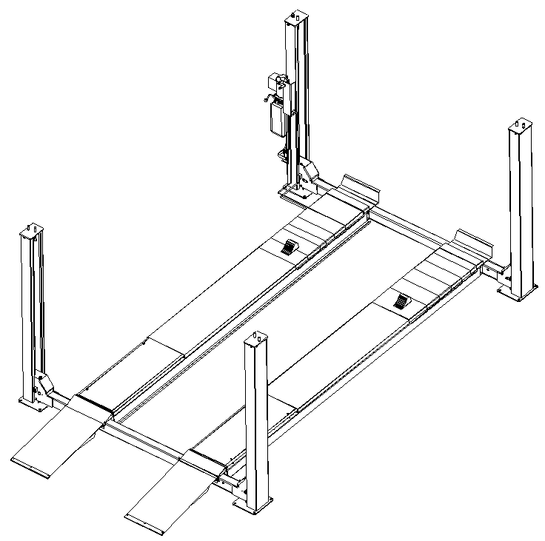

Special Note

▲ Shipping process caused damage to the equipment by the purchaser claims to the carrier unit.

▲ Design and manufacturing, taking into account the safety performance. However, proper training and careful operation can also increase security. Not reading the manual, shall not operator repair the device.

▲ To identify the requirements of the motor nameplate power, current status, must be professionally qualified electrician electrical connection.

▲ To ensure that the life safety and to avoid electric shock accident occurred, to ensure reliable grounding of all ground.

▲ The anger of the local structure of the product improvement without notice. Under no obligation to update on previous sales of the product.

▲ Please read and fill out the last page of this manual, warranty card, and feedback to the dealer and the Company for the record. For providing one of the basis of after-sales service.Otherwise regarded as a waiver of the right to enjoy the same services at your own risk.

▲ Shall enhance more than the rated lift-off weight (4.0 tons) load.

▲ Reading devices on the warning signs carefully.

Table of Contents

1. Equipment performance
2. The basic parameters
3. Equipment dimensions
4. The installation of equipment
5. Equipment debugging
6. Equipment maintenance and inspection
7. Pneumatic insurance installation and instruction
8. Parts of the device exploded view and schedule
9. Hydraulic system equipment and electrical component
10. Common troubleshooting method
11. Packing list
12. Wearing part list

Equipment performance

● Set inspection, maintenance, four positioning as a whole, and good appearance.

● Hydraulic cylinders drive, rope drive, quiet working environment.

● Mechanical safety lock, can any of the top job at the desired height, safe and reliable.

● The levelness of concrete slab in the locked position can be adjusted to meet the needs of the precise wheel alignment.

● Common type designed for the inspection and repair purposes.

● Wheel alignment special. Additional two sets of sliding panels and a secondary lifting.

The basic parameters

1. A rated lifting weight: 4.0 Tons

- Lifting height: 1850 mm

- Min height: 205 mm

4. Runway Length: 4600 mm

5. The runway width: 508 mm

6. Runway Inside Pitch: 1000-1100 mm

7. Power supply: 240V/50HZ 1PH (2.2KW)

Equipment Dimensions

Check the FIG 1

The installation of equipment

The first step: site selection

Before installing the new lift, pay attention to the following matters:

(1) The location of the lift, according to the design and planning of the entire plan requirements, as far as possible, place the dimension there is sufficient space.

(2) According Figure 1 foundation size , determine the installation location and carry out the dash.

(3) Make sure the ground does not have any defects to ensure that the basis of concrete strength of 3000psi (2.1kg/mm ²)

(4) Open the box to check whether the missing pieces and transport damage. Required by the packing list.

Step 2: Connect the runway and the beam (Figure 2)

Step 3: Install the four column parts (Figure 2) (Figure 3)

Step 4: Install the power unit and pipeline joints(Figure 3) (Figure 7)

Step 5: Install a safety lock device (Figure 2) (Figure 4) (Figure 10)

Step 6: The need to do a wheel alignment equipment, installation,sliding, corner plate (user optional) and the second lifting

Step 7: The power supply according to the requirements on the motor nameplate, add hydraulic oil.

Step 8: Jog up, observe the correct rope position (Figure 9) (Figure 10) . Relieve the support under the runway to runway decreased to the lowest point, adjusting the tension of the wire rope, the four unanimously.

Step 9: Adjust the position between the column components and beams (Figure 4) . Requirements limit block close to the column side. Iron inserts to adjust the vertical column and the ground plane. Drilling bolt hole and tighten the bolt.

Step 10: Adjust the levelness of the runway (Figure 2) (Figure 10). Ascending to a height. Lock levelness, When need to adjust. Adjust nut（22） to the required position. Then lock.

Step 11: Install all shrouding (Figure 2) .

Step 12: Install running board and slopes (Figure 2)

Step 13: Stick all labels and finishing.

The debugging

☞ Hydraulic station to fill the tank pressurized oil N32 or N46

☞ To move the start button, so that the runway frame rise, removal of the support frame. Special attention to the first jog observe whether rope in the embrace of a round tank, location to be correct.

☞ Pull the handle pressure in the unlocking state to observe whether the lock block can enter the square hole of insurance pieces effectively, if necessary, adjust the lift rod length (Figure 10 ).

☞ Down the runway rack to lowest position, adjust the nuts on the four wire rope, so that tension is the same. (Figure 2.10).

☞ Adjust the level of the runway: press the start button, the runway frame up by the appropriate location, drop the runway according to decline in valve on the hydraulic station. Matter of four lock set limit Article hole. Level detection level of the runway,to be adjusted with reference to the installation Step 10.

☞ No-load test up and down twice, check each part is working properly. Runway lock reliability checks, and more repeated several times re-planted on the car to check the hydraulic system is working properly.

Special attention

▲ Vehicles parked on the runway braking and tire wedge.

▲ Lifting and lowering vehicles, pay attention to people and things around to keep their distance and not close to the lift.

▲ Maintenance man to enter the work area, check the runway should be properly locked in the column lift.

▲ Four column installation should be vertical to the ground plane, otherwise be dangerous to use!

▲ Decline before the operation must be the first point of action to rise a little, so that the lock block to leave the lift bar square hole in order to decline. Otherwise it will cause damage to the control mechanism

Maintenance and inspection notes

Routine maintenance and inspection

- Check work location of safety lock when operation
2. Check safety lock and unlock the insurance piece and padlock
3. Check hydraulic fittings, hose leaks
4. Check the wire rope connections - is bent, broken, loose.
5. Check the wear of the wire rope lifting process.
6. Check all retainer connection must be reliable connection.
7. Check all bolts, nuts, screws connection - found loose shall immediately tighten
8. Check wires and switches for damage.
9. Check expansion bolts around the foundation strength.
10.After the lift is put into use, oil refers to the gun at least once a year or at regular intervals on the cable axle lubrication

Weekly maintenance and inspection

1. Check the bolts strength and connections found loose shall immediately tighten
2. Inspection inflation bolt around the foundation strength
3. Check the hydraulic oil liquid level
4. Check and tighten loose bolts, nuts, screws
5. Check all pulley and pulley axle

Weekly maintenance and inspection

1. Lubricate the cable wheel and cable axle
2. Check the wire rope wear, severe wear and tear be replaced immediately
3. Replace the hydraulic oil.

Pneumatic insurance installation and instruction

- Installation
Installation oil-mist separator(41) (Figure 3),installation hand valve（46）（Figure 3),Then press the up button to the required height, connect air pipe 127,129,134. Connect intake-tube, then pull our the nut which on oil-mist separator, adjust the pressure to 0.6MPA-0.8MPA，then press the nut back.

- Instruction

- Rising the lift to the required height, press the down handle A8 ( Figure 11), the devices locking, convenience for work.
- After maintain, Point press the up button, it will raise a little, then release the hand valve (46) (Figure 3), then press the down handle A8，the lift will down to the lowest position.

Parts of the device exploded view and schedule

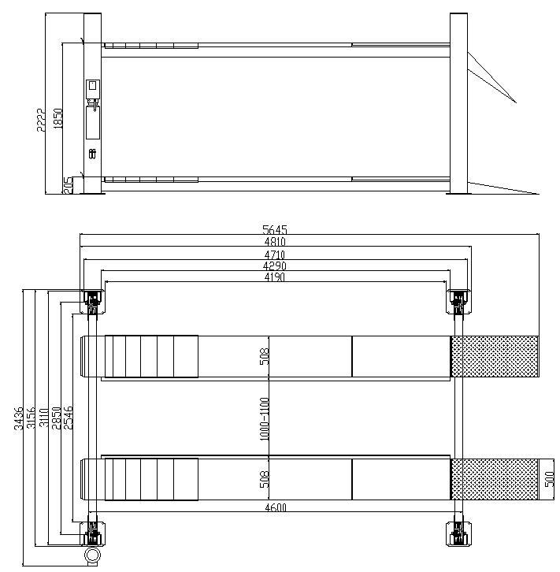

Figure 1

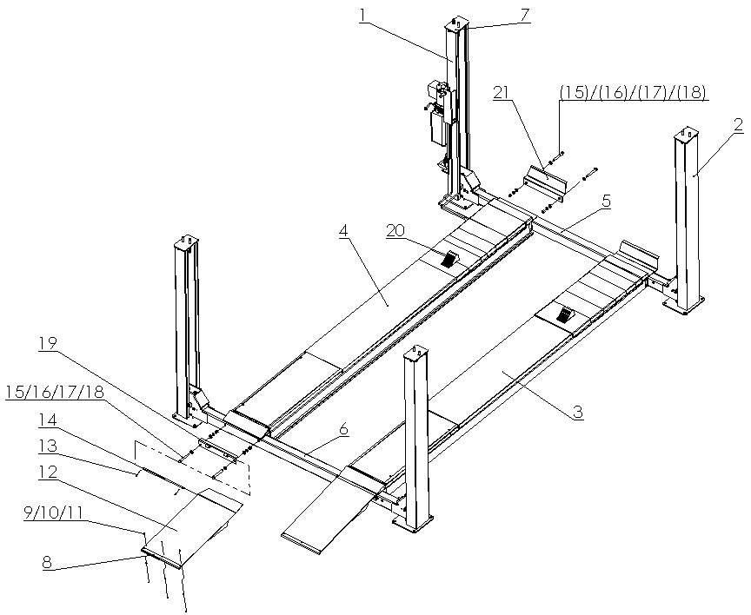

Figure 2

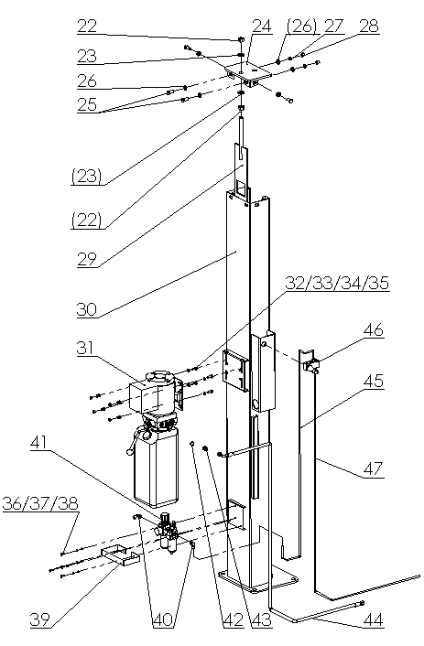

Figure 3

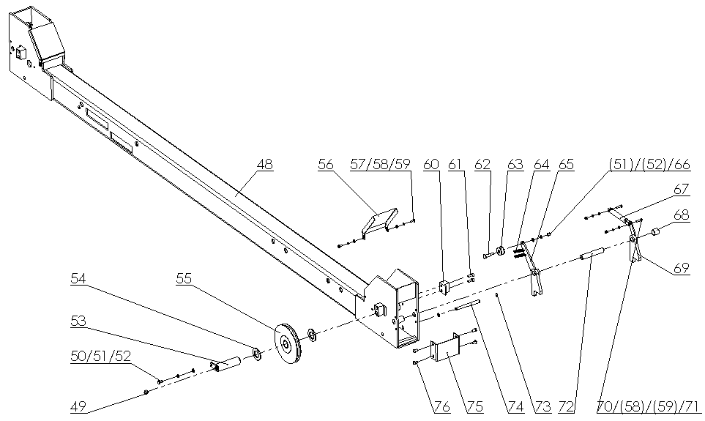

Figure 4

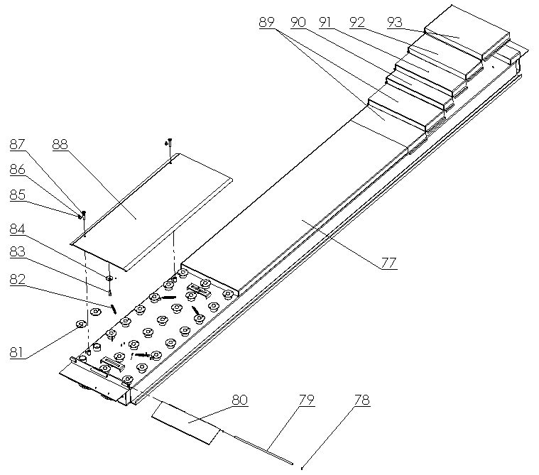

Figure 5

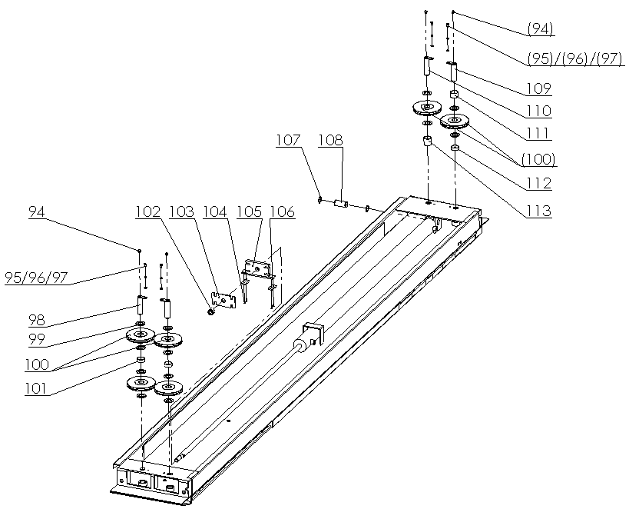

Figure 6

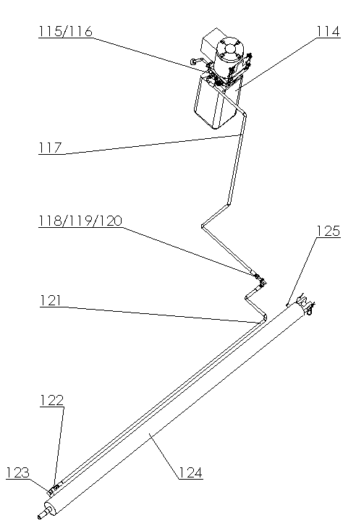

Figure 7

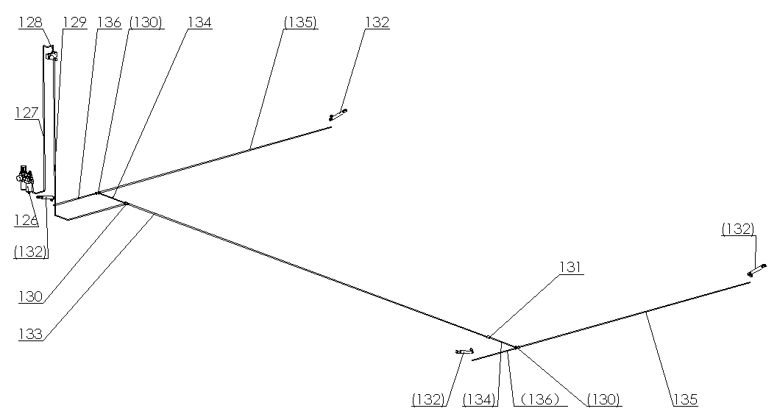

Figure 8

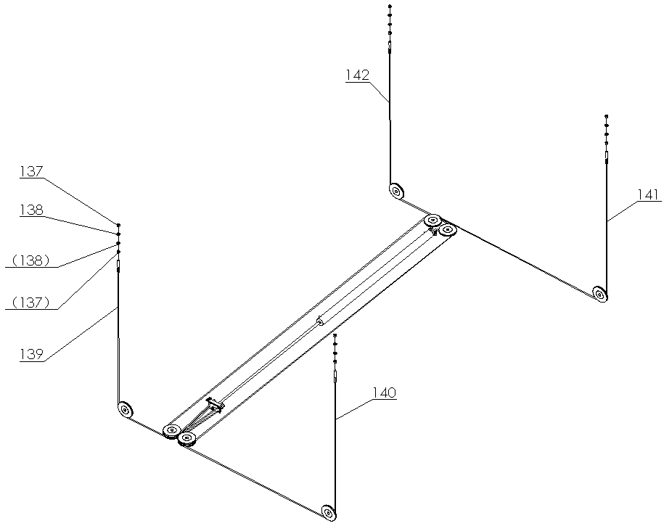

Figure 9

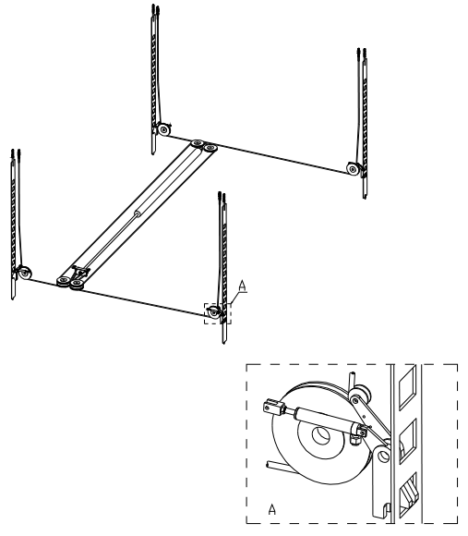
Figure 10

Part list
No. | Name | Qty | Remark
1 | Main column | 1
2 | Subsidiary column | 2
3 | Subsidiary runway | 1
4 | Main runway | 1
5 | Beam assembly 1 | 1
6 | Beam assembly 2 | 1
7 | Column top cover assembly | Each 2 | Bilateral symmetry
8 | Sliding block | 2
9 | Screw M5*16 | 6
10 | Flat gasket 5 | 6
11 | Nut 5 | 6
12 | Up ramp | 2
13 | R type pin | 4
14 | Up ramp pin | 2
15 | Hexagon bolt M18*140 | 8
16 | Flat gasket 18 | 16
17 | Spring washer 18 | 8
18 | Nut 18 | 8
19 | Up ramp adapting piece | 2
20 | Tire wedge | 2
21 | Stop running plate | 2
22 | Nut M18 | 8
23 | Gasket 18 | 8
24 | Column top cover welding assembly | Each 2 | Bilateral symmetry
25 | Screw M12*30 | 16
26 | Gasket 12 | 32
27 | Spring wahser 12 | 16
28 | Nut 12 | 16
29 | Insurance welding assembly | 4
30 | Main column | 1
31 | Power unit | 1
32 | Screw M8*25 | 4
33 | Gasket 8 | 8
34 | Spring washer 8 | 4
35 | Nut 8 | 4
36 | Cross head screw M6*16 | 4
37 | Spring washer 6 | 4
38 | Flat gasket | 4
39 | Protector support | 1
40 | Right angle air joint | 2
41 | Big oil-mist separator assembly | 1
42 | Copper backing | 1
43 | American system 9/16 Through joint | 1
44 | Oil tube L=2100mm | 1
45 | Air pipe L=1250mm | 1
46 | Hand valve assembly | 1
47 | Air pipe L=2600mm | 1
48 | Beam assembly 1 | 1
49 | Nipple | 4
50 | Hexagon bolt M8*16 | 4
51 | Spring washer 8 | 8
52 | Flat gasket 8 | 8
53 | Beam pulley axle | 4
54 | Flat gasket 30 | 8
55 | Pulley | 4
56 | Beam side protector | 4
57 | Cross recess pan head screw M6*16 | 8
58 | Spring washer 6 | 16
59 | Flat gasket 6 | 16
60 | Beam column limit block | 8
61 | Hexagon socket screw M8*20 | 16
62 | Beam safety limit bolt | 4
63 | Safety limit wheel | 4
64 | Tension spring | 8
65 | Stop pulling hook | Each 2 | Bilateral symmetry
66 | Self-locking nut M8 | 4
67 | Air cylinder assembly | 4
68 | Beam safety stop collar | 4
69 | Air safety hook | Each 2 | Bilateral symmetry
70 | Hexagon bolt M6*25 | 8
71 | Self-locking nut M6 | 8
72 | Beam safety axle | 4
73 | Axle bumper 12 | 8
74 | Wire rope limit bar | 4
75 | Insurance support | 4
76 | Screw M8*16 | 16
77 | Main runway | 1
78 | Axle bumper 10 | 4
79 | Small up ramp pin | 2
80 | Main up ramp plate | 2
81 | Universal ball | 48
82 | Tension spring | 8
83 | Hexagon socket cap screw M10*30 | 4
84 | Big flat gasket inner12 outer40 | 4
85 | Key ring | 8
86 | Chain | 4
87 | Slide plate pin | 4
88 | Slide plate cover | 2
89 | Active plate 205 | 4
90 | Active plate 100 | 2
91 | Active plate 105 | 2
92 | Active plate 180 | 2
93 | Active plate 300 | 2
94 | Nipple | 4
95 | Hexagon bolt M8*16 | 4
96 | Spring washer 8 | 4
97 | Flat gasket 8 | 4
98 | Pulley axle 1 | 4
99 | Flat gasket 33 | 12
100 | Wire rope | 6
101 | Platform active check ring18 | 2
102 | Self-locking nut M24 | 1
103 | Wire rope lock plate | 1
104 | Cross sunk head screw M6*16 | 4
105 | Cylinder pulling plate | 1
106 | Nylon cushion | 2
107 | Axle bumper 35 | 2
108 | Oil cylinder axle | 1
109 | Pulley axle 2 | 1
110 | Pulley axle 3 | 1
111 | platform active check ring 30 | 1
112 | platform active check ring 16 | 1
113 | platform active check ring 45 | 1
114 | Power unit | 1
115 | Copper backing | 1
116 | Through joint | 1
117 | Oil tube L=2100mm | 1
118 | Flat gasket 14 | 1
119 | American system nut 9/16 | 1
120 | Big angle bending joint | 1
121 | Oil tube L=1800mm | 1
122 | Explosion-proof valve assembly | 1
123 | Small angle bending | 1
124 | Oil cylinder | 1
125 | Silencer | 1
126 | Oil-mist separator | 1
127 | Air pipe L=1250mm | 1
128 | Oil-mist separator | 1
129 | Air pipe L=2600mm | 1
130 | Tracheal tee | 3
131 | Tracheal pass-through | 1
132 | Air cylinder | 4
133 | Air pipe 1 | 1
134 | Air pipe 2 | 2
135 | Air pipe 3 | 2
136 | Air pipe 4 | 2
137 | Nut M20 | 8
138 | Flat gasket 20 | 8
139 | Wire rope L=3260mm | 1
140 | Wire rope L=4770mm | 1
141 | Wire rope L=9510mm | 1
142 | Wire rope L=8000mm | 1

HYDRAULIC SYSTEM, ELECTRIC COMPONENT
AND WIRING DIAGRAM
1.Power unit out-looking explosion figure
2.Hydraulic system of equipment
a.Hydraulic schematic diagram
b.Hydraulic components list
c.Hydraulic system working principle
d.Electric schematic diagram

Power unit out-looking explosion figure

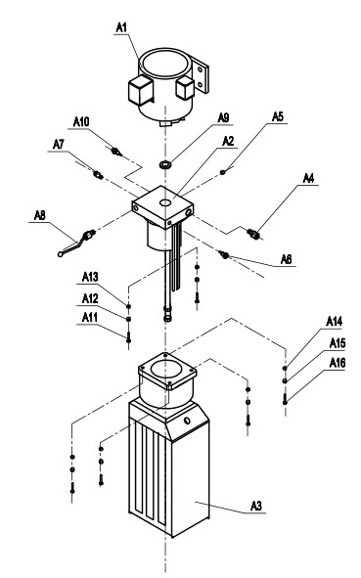
Figure 11

No. | Name. | Qty | No. | Name | Qty
A1 | Motor | 1 | A9 | Sheet gasket | 1
A2 | valve element | 1 | A10 | Choke plug | 1
A3 | Tank | 1 | A11 | M5X40 hexagon screw | 4
A4 | Down-regulating valve | 1 | A12 | Φ5 Flat gasket | 4
A5 | Choke plug | 1 | A13 | Φ5 Spring washer | 4
A6 | Oil-out | 1 | A14 | M6X20 hexagon screw | 4
A7 | Oil-out | 1 | A15 | Φ6 Flat gasket | 4
A8 | Hand valve | 1 | A16 | Φ6 Spring washer | 4

2．Hydraulic system
a．Hydraulic principle
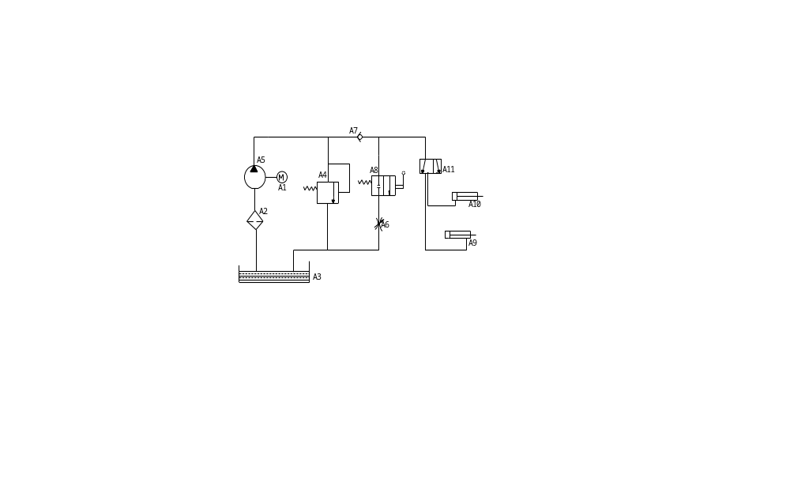

b．Parts list

A11 | Ball valve |  |  | 1
A10 | Cylinder |  |  | 1
A9 | Cylinder |  |  | 1
A8 | Hand valve |  |  | 1
A7 | One-way valve |  |  | 1
A6 | Throttle valve |  |  | 1
A5 | Oil pump |  |  | 1
A4 | Flood valve |  |  | 1
A3 | Tank |  |  | 1
A2 | Filter |  |  | 1
A1 | Motor |  |  | 1
No. | Name | Model | Standard | Qty | Remark

c. The hydraulic system works as follows:

When pressing the start button on the hydraulic station , the motor starter to drive the pump suction pressure from the tank and oil is carried into the serial A9 fuel tank, so that the piston rod to move. The A4 relief valve closed, the pressure is fine before leave factory . To ensure that the requirements of lifting rated load. However, the system pressure exceeds the limit, automatic relief valve unloading. Release the start button, stop oil supply to enhance the end, began operations work. If you decline, the first point of action to rise a little, after the mechanical safety lock is opened, pressing the manual valve A8 and began unloading decreased.

Electrical schematic diagram (240V single-phase motor) (415V three-phase optional)
(* Installation sure to follow the schematic wiring to ensure reliable the ground at the ground, the input power leakage, over-current protection switch must be set)

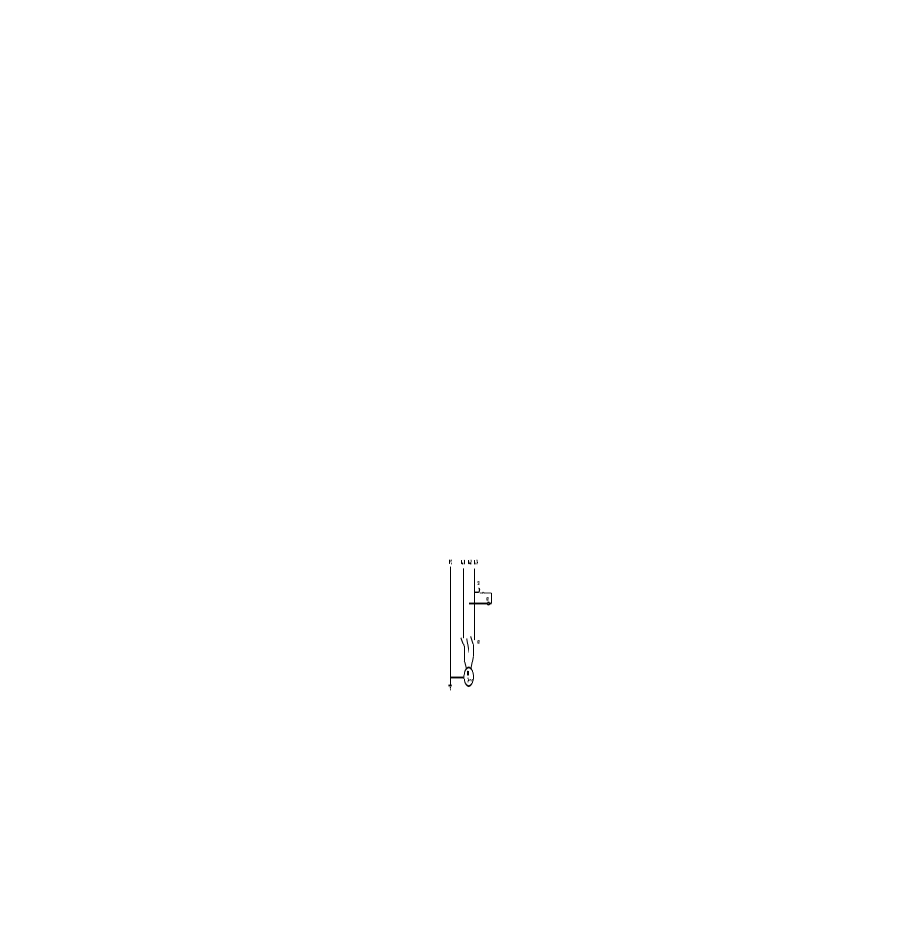

SB | button | LXW5-11M/L | 1
KM | exchange contractor | CJX1-6.3/01-240V | 1
No. | Name | Model | Qty

Trouble shooting

No. | Symptom | Eliminating methods
1 | A motor does not turn | ● check the power supply has power  ● Check the motor connection box wiring is loose
2 | motor rotation position of pressure oil | ● Three-phase electric rotating in the wrong direction, swap in which two into line.  ● Check that the fuel tank suction tube is off
3 | Hydraulic lift after the slow decline in(Pressure bad) | ● cleaning one-way valve and valve of the hydraulic station.
4 | Security lock laughs at locksmith | ● observe the position of locksmith security hook plate is normal.  ● observed the location of column is correct.  ● Check the return spring safety hook plate
5 | motors, electrical failure | ● Promptly cut off the power to inspect, repair and replacement by a professional electrician..
6 | A motor does not turn | ● check the power supply has power  ● Check the motor connection box wiring is loose

Standard part packing list

No. | Part name | Name | Qty | Remark
1 | Standard part | 16×120 Foundation bolt | 16set | With nut/ flat gasket/spring washer
1 | Standard part | M8Ｘ25 Hexagon bolt | 4 | Power unit
1 | Standard part | M12×30 Hexagon bolt | 16 | Top cover
1 | Standard part | Round flat nose pad | 20
1 | Standard part | tier | 10
1 | Standard part | M14Ｘ1.5-M16Ｘ1. | 1 | Joint of power unit
1 | Standard part | 14 cooper backing | 2 | Joint Sealing element
1 | Standard part | “0”type sealing element | 1
1 | Standard part | 2．1m oil tube | 1
1 | Standard part | 8-2600 air pipe | 1 | Main insurance
1 | Standard part | 8-1250 air pipe | 1 | Oil-mist separator to hand valve
1 | Standard part | Hand valve | 1
1 | Standard part | Oil-mist separator | 1
1 | Standard part | Screw M6Ｘ15 | 4 | Oil-mist separator with nut, double flat gasket, spring washer
1 | Standard part | M8×20 hexagon socket screw | 16
1 | Standard part | M18×140 Hexagon bolt | 8
1 | Standard part | Limit block | 8
1 | Standard part | Brake block | 2
1 | Standard part | Nipple | 8 | Pulley axle
1 | Standard part | 18 Flat gasket | 16
1 | Standard part | 18 Spring washer | 8
1 | Standard part | 12 Flat gasket | 32 | .
1 | Standard part | 8 Flat gasket | 8
1 | Standard part | 6 Flat gasket | 4
1 | Standard part | 18 Nut | 8
1 | Standard part | 12 Nut | 16
1 | Standard part | 8 Nut | 4
1 | Standard part | 12 Spring washer | 16
1 | Standard part | 8 Spring washer | 4
1 | Standard part | 6 Spring washer | 4

Wearing parts list

No. | Model | Name
1 |  | Beam pulley (178-32)
2 |  | Platform pulley (178-32)
3 |  | Oil cylinder slide block
4 |  | Beam limit wheel
5 |  | Air cylinder16X45
6 |  | Wire rope L=3260mm
7 |  | Wire rope L=4770mm
8 |  | Wire rope L=9510mm
9 |  | Wire rope L=8000mm
10 |  | Hand valve（TSV86522S)
11 |  | Oil-mist separator(AFR-2000)
12 |  | Tire wedge
13 |  | Beam limit block

