PP-8SU
Installation & Operation
Manual

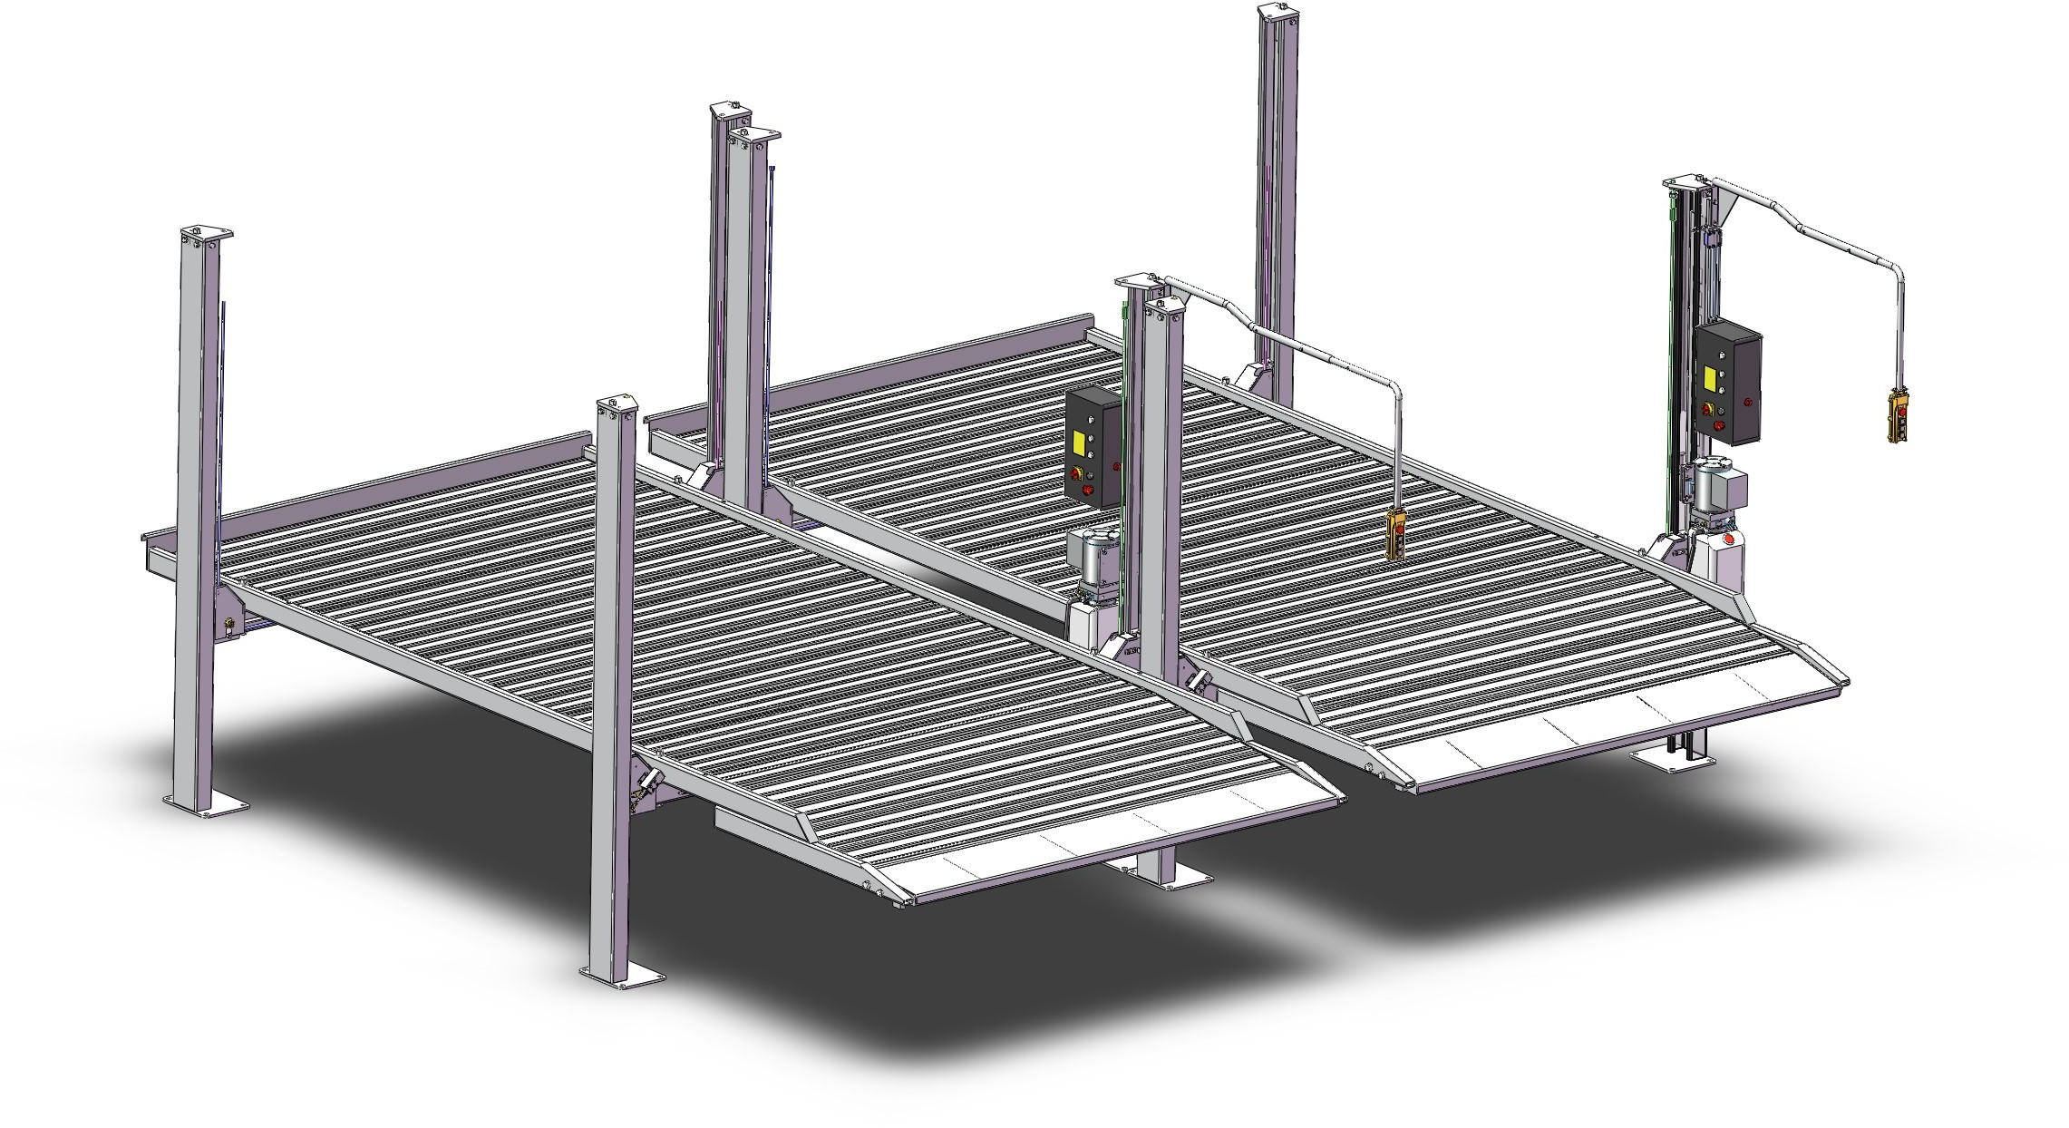

Special Note
▲ Shipping process caused damage to the equipment by the purchaser claims to the carrier unit.

▲ Design and manufacturing, taking into account the safety performance. However, proper training and careful operation can also increase security. Not reading the manual, shall not operator repair the device.

▲ To identify the requirements of the motor nameplate power, current status, must be professionally qualified electrician electrical connection.

▲ To ensure that the life safety and to avoid electric shock accident occurred, to ensure reliable grounding of all ground.

▲ The anger of the local structure of the product improvement without notice. Under no obligation to update on previous sales of the product.

▲ Please read and fill out the last page of this manual, warranty card, and feedback to the dealer and the Company for the record. For providing one of the basis of after-sales service.Otherwise regarded as a waiver of the right to enjoy the same services at your own risk.

▲ Shall enhance more than the rated lift-off weight (3.6 tons) load.

▲ Reading devices on the warning signs carefully.

Table of Contents

- Lift Performance............................................................................................................4

- The Basic Parameters.....................................................................................................4

- Dimensions of Lift.........................................................................................................5

- The Installation of Lift...................................................................................................5

- Lift Debugging...............................................................................................................6

- Lift Maintenance and Inspection....................................................................................7

- Parts of the Device Exploded View and Schedule.........................................................9

- Hydraulic System and Electrical Component.............................................................62

- Common Troubleshooting Method..............................................................................67

- Packing List................................................................................................................68

- Wearing Part List........................................................................................................69

1. Lift Performance

- Parking lift, beautiful appearance, save space

- Hydraulic cylinders drive, rope drive, quiet working environment.

- Mechanical safety lock, can any of the top job at the desired height, safe and reliable.

- The levelness of concrete slab in the locked position can be adjusted to meet the needs of the precise wheel alignment.

2.The Basic Parameters

- Max.Lifting Weight: 8000lb（3600KG）2.Lifting Height: 1987mm
3.Min Height: 189mm 4.Runway Length: 5000mm
5.The Runway Width: 2212mm
7.Power supply: 240V 50HZ or According customer’s requirement

3.Dimensions of Lift
Check the (FIG 1 , FIG2 , FIG3 )

4.The Installation of Lift

The first step: site selection
Before installing the new lift, pay attention to the following matters:

- The location of the lift, according to the design and planning of the entire plan requirements, as far as possible, place the dimension there is sufficient space.

- According Figure 1 foundation size , determine the installation location and carry out the dash.

- Make sure the ground does not have any defects to ensure that the basis of concrete strength of 3000psi (2.1kg/mm ²)

- Open the box to check whether the missing pieces and transport damage. Required by the packing list.

Step 2: Connect column and beam （Z-1,Z-2），Install column top cover and lock ladder then drop the safety hook into square hole of lock ladder（Z-2,Z-2-1,Z-2-2）。

Step 3：connect beam and runway.（Z-3,Z-3-1,Z-3-2,）。

Step 4：Install control box, power unit, travel switch, operating lever and oil tube（Z-4,Z-4-1,Z-4-2,Z-4-3）。

Step 5：Install limit switch touch plate and protect cover （Z-5,Z-5-1）。

Step 6: Install longitudinal beam, up ramp, stop running plate. （Z-6，Z-6-1，Z-6-2，Z-6-3）

Step 7: Install middle galvanized plate（Z-7,Z-7-1）。

Step 8：The power supply according to the requirements on the motor nameplate, add hydraulic oil.

Step 9：Jog up, observe the correct rope position 。 Relieve the support under the runway to runway decreased to the lowest point, adjusting the tension of the wire rope, the four unanimously.

Step 10：Adjust the position between the column components and beams . Requirements the slide board closest to column. Iron inserts to adjust the vertical column and the ground plane. Drilling bolt hole and tighten the bolt.。

Step 11：Adjust the levelness of the runway. Ascending to a height. Measure the level, When need to adjust.

Adjust nut to the required position. Then lock. 。

Step 12：Stick all labels and finishing.

5.The debugging

☞ Hydraulic station to fill the tank pressurized oil N32 or N46

☞ To move the start button, so that the runway frame rise, removal of the support frame. Special attention to the first jog observe whether rope in the embrace of a round tank, location to be correct.

☞ Press the down button lift in the unlocking state to observe the safety hook ability to effectively disengage the lock ladder square hole

☞ Down the runway rack to lowest position, adjust the nuts on the four wire rope, so that tension is the same.

☞ No-load test up and down twice, check each part is working properly. Runway lock reliability checks, and more repeated several times re-planted on the car to check the hydraulic system is working properly.

Special attention

▲ Vehicles parked on the runway braking and tire wedge.

▲ Lifting and lowering vehicles, pay attention to people and things around to keep their distance and not close to the lift.

▲ Four column installation should be vertical to the ground plane, otherwise be dangerous to use!

▲ Decline before the operation must be the first point of action to rise a little, so that the lock block to leave the lift bar square hole in order to decline. Otherwise it will cause damage to the control mechanism

6.Maintenance and Inspection

Routine maintenance and inspection

- Work location of an operation to check the safety lock

- Check safety lock and unlock the lift bar and padlock

- Check the wire rope connections - is bent, broken, loose.

- Check the wire rope connections - is bent, broken, loose.

- Check the wear of the wire rope lifting process.

- Check all retainer connection must be reliable connection.

- Check all bolts, nuts, screws connection - found loose shall immediately tighten

- Check wires and switches for damage.

- Check expansion bolts around the foundation strength.

- After the lift is put into use, oil refers to the gun at least once a year or at regular intervals on the cable axle lubrication

Weekly maintenance and inspection

- Check the bolts strength and connections found loose, tighten immediately

- Inspection inflation bolt around the foundation strength

- Check the hydraulic oil liquid level

- Check and tighten loose bolts, nuts, screws

- Check all embrace round and embrace the axle with

Monthly maintenance and inspection

1.Lubricate the cable wheel and cable axle

2.Check the wire rope wear, severe wear and tear be replaced immediately

3.Replace the hydraulic oil.

7.Parts of the device exploded view and schedule

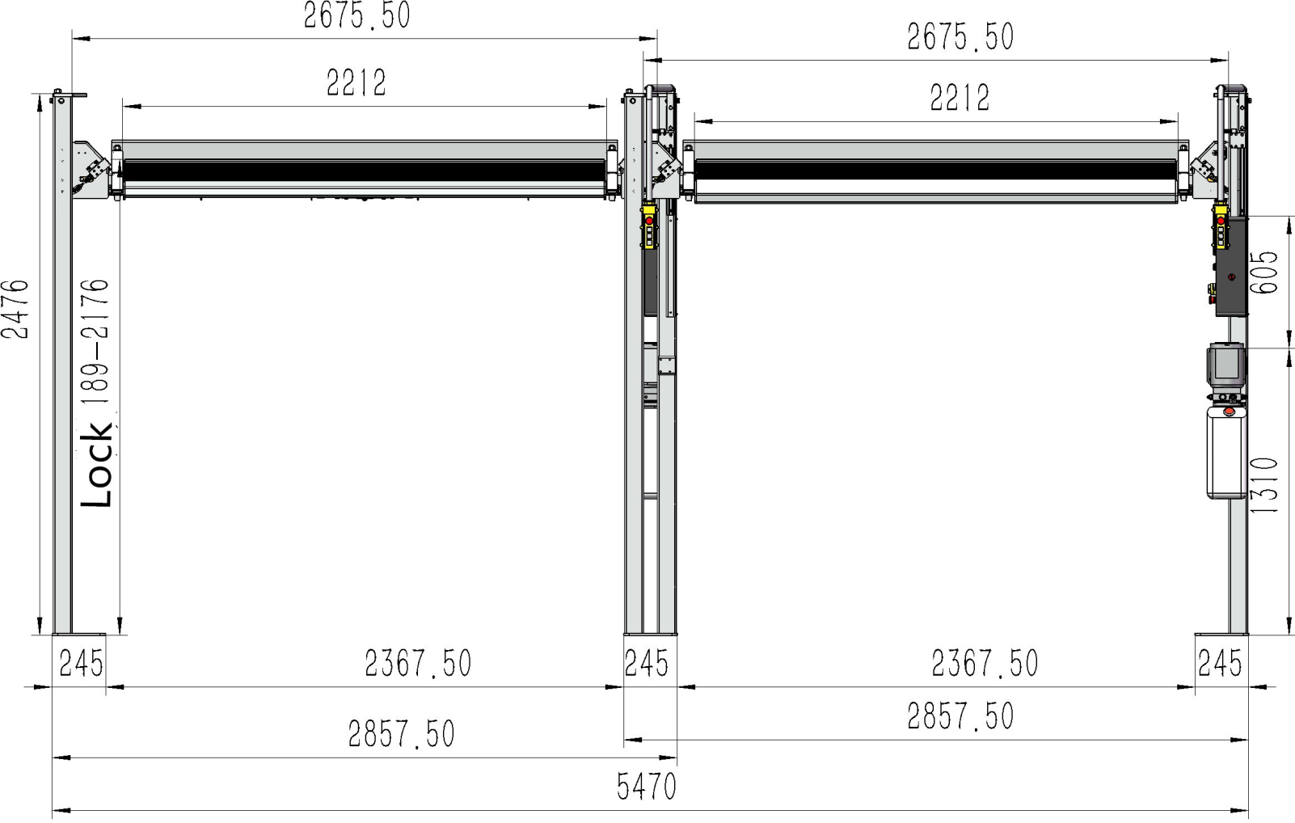

Figure 1

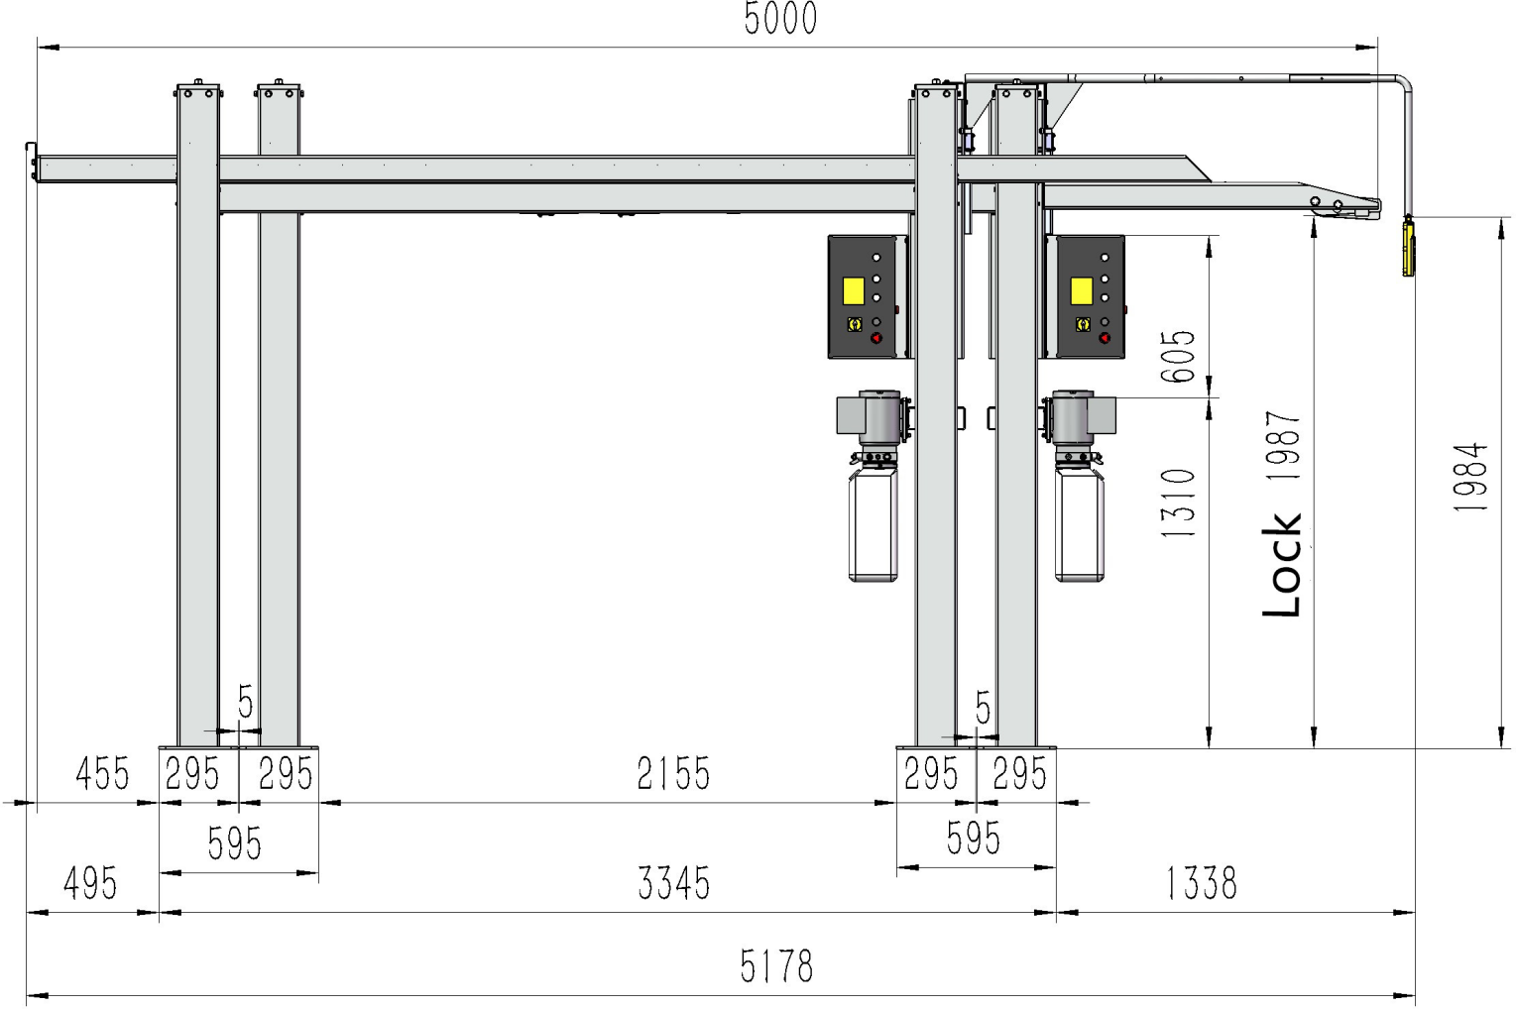

Figure 2

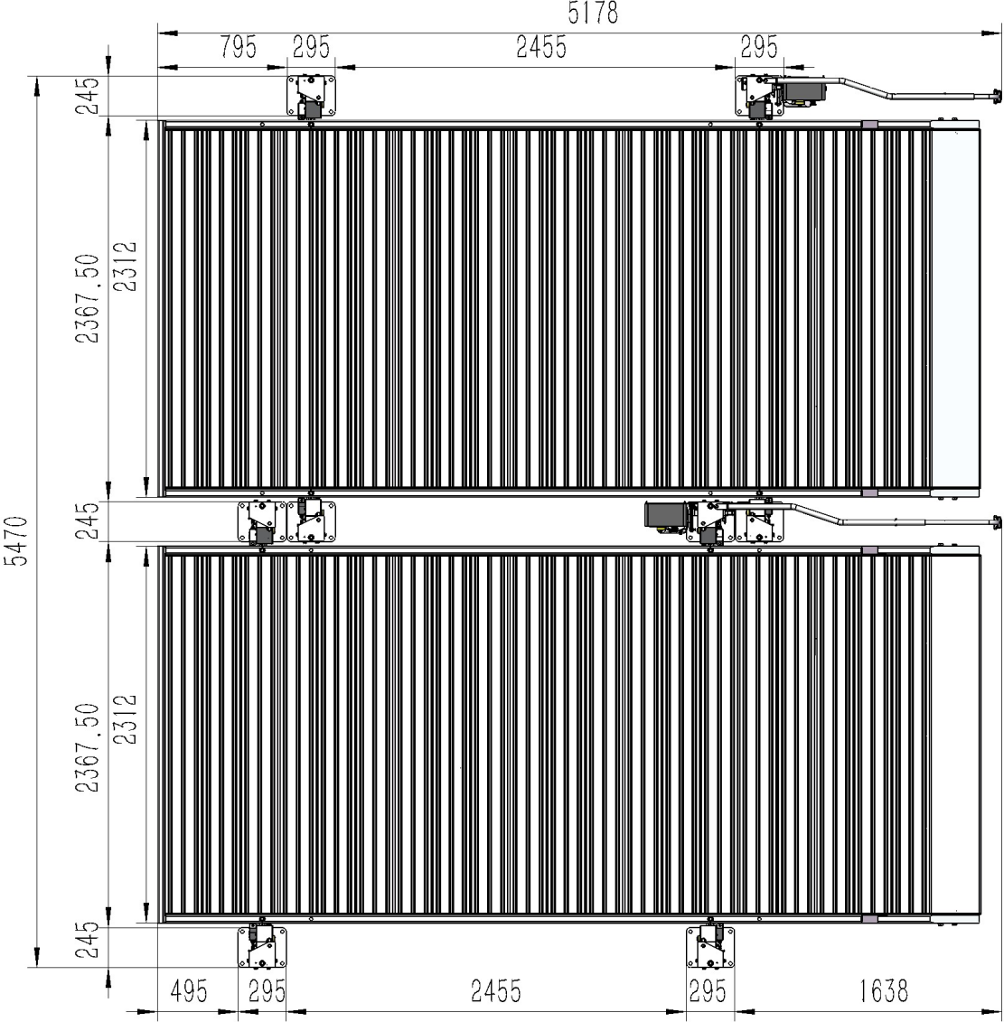

Figure 3

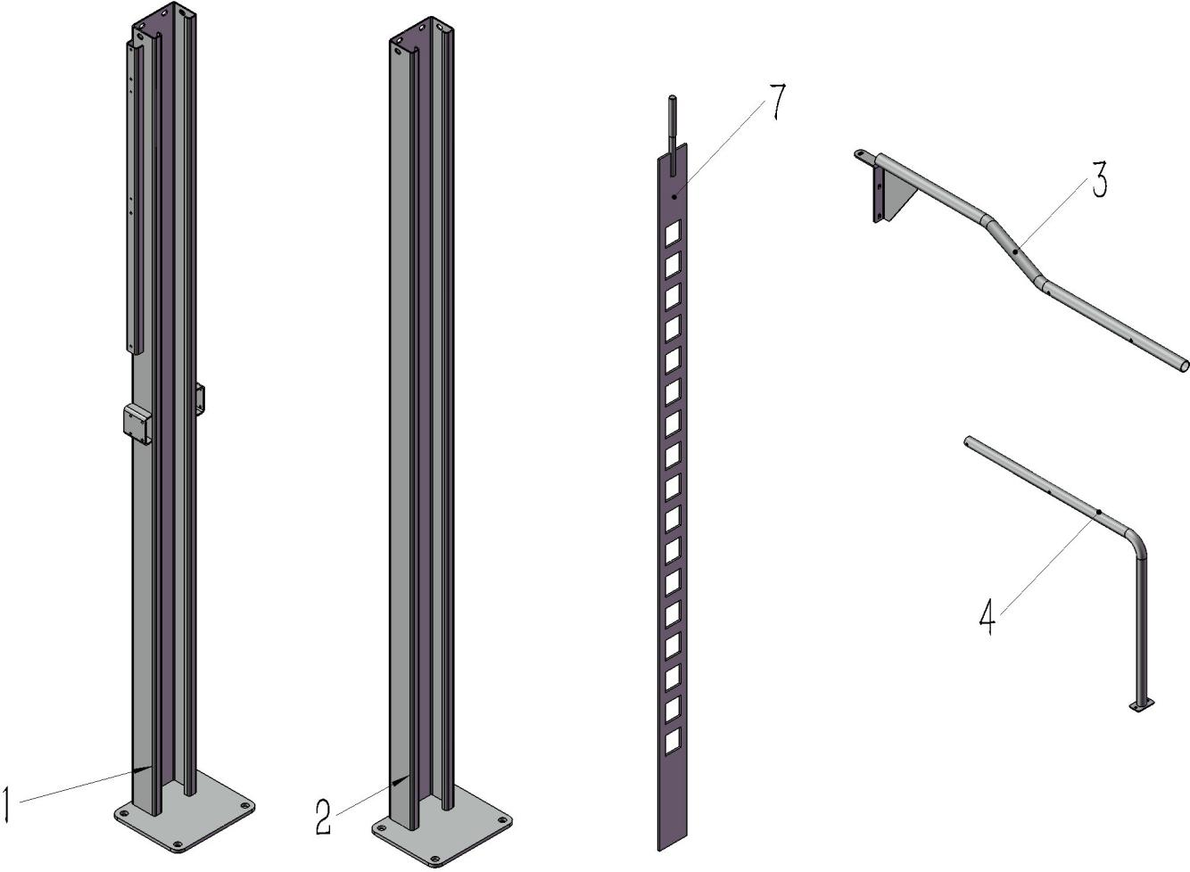

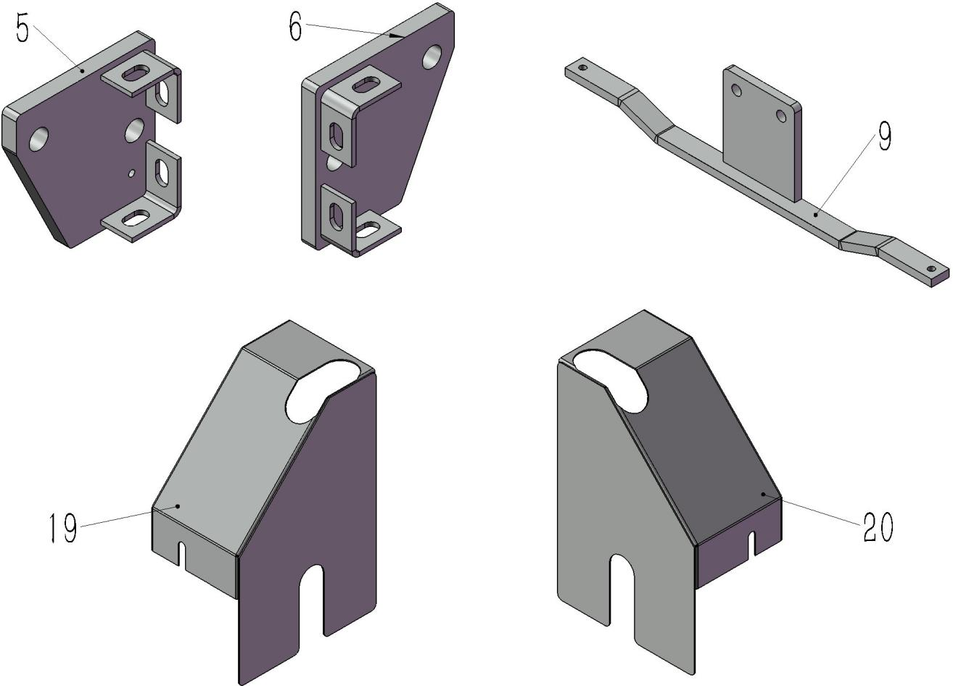

8-13-21-22-23

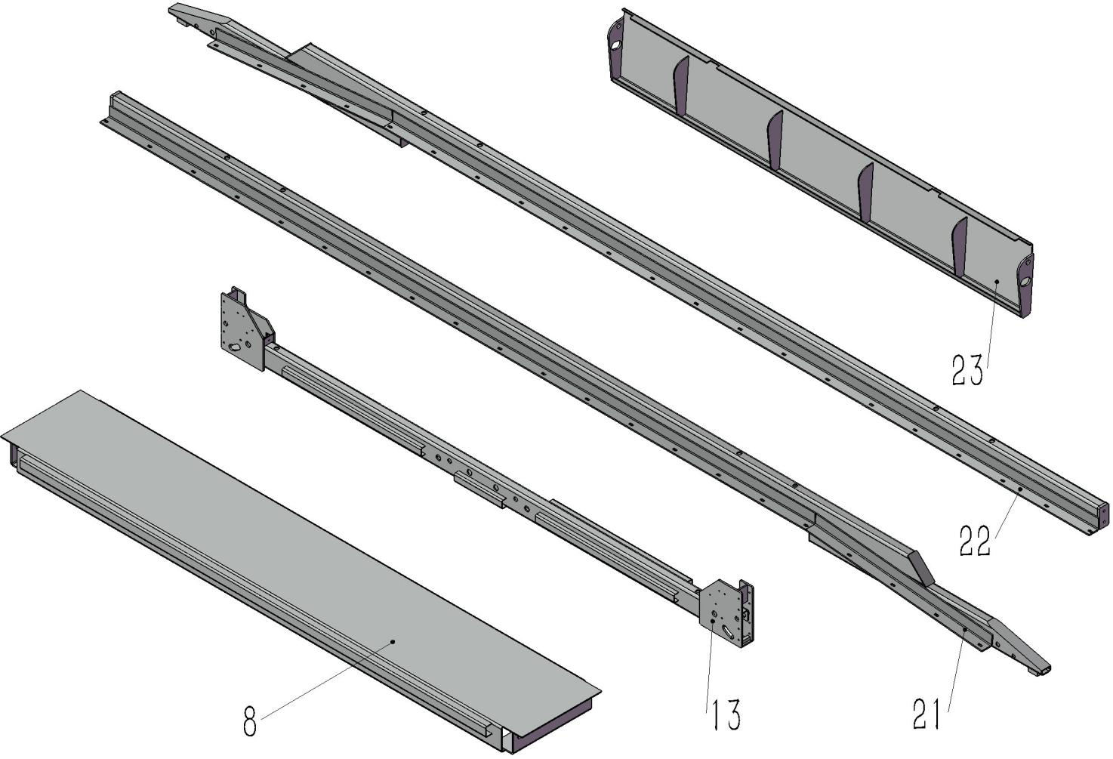

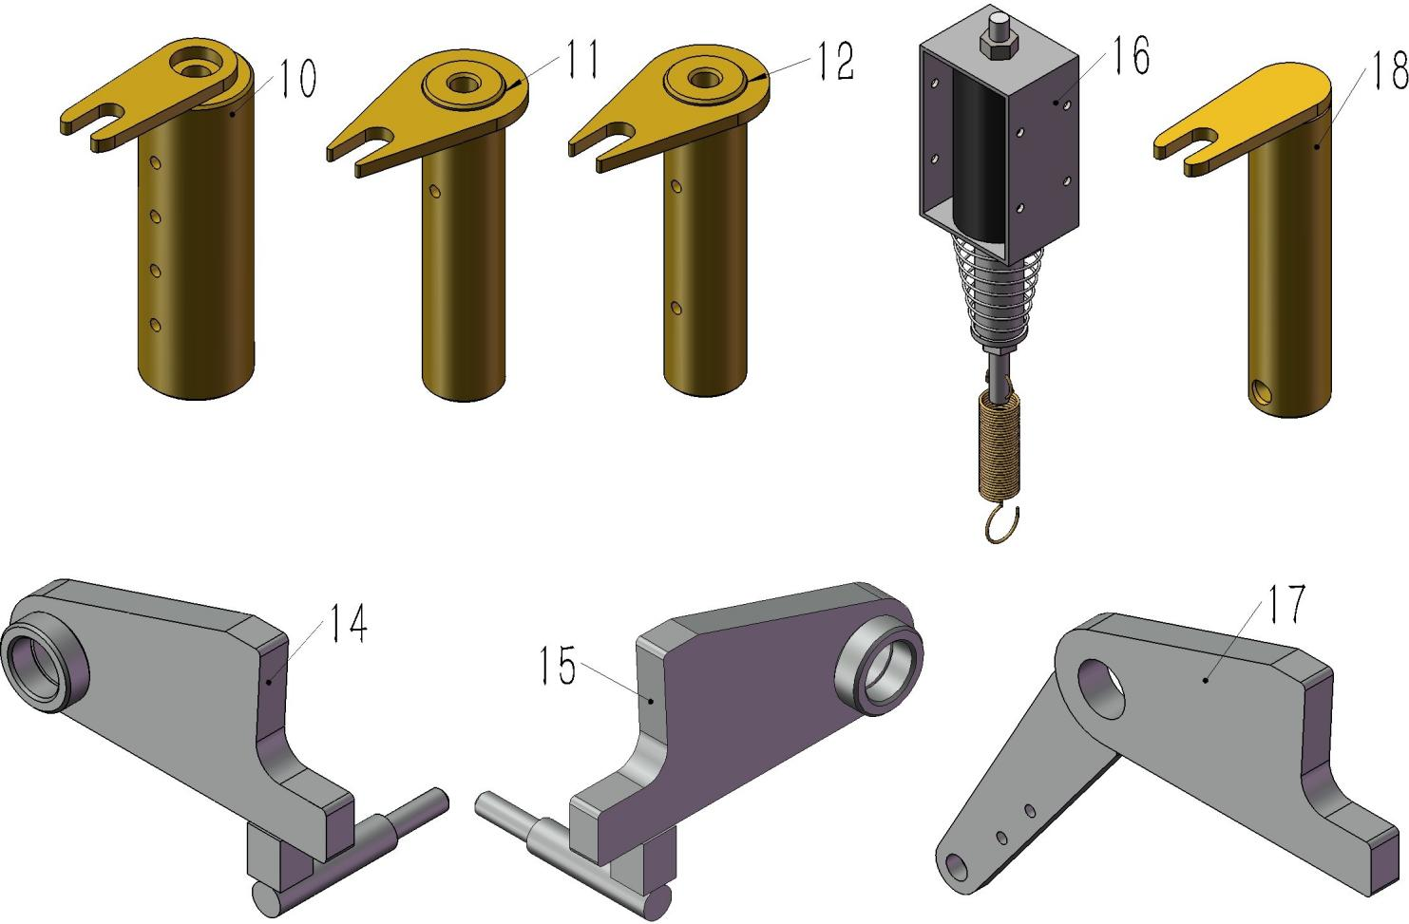

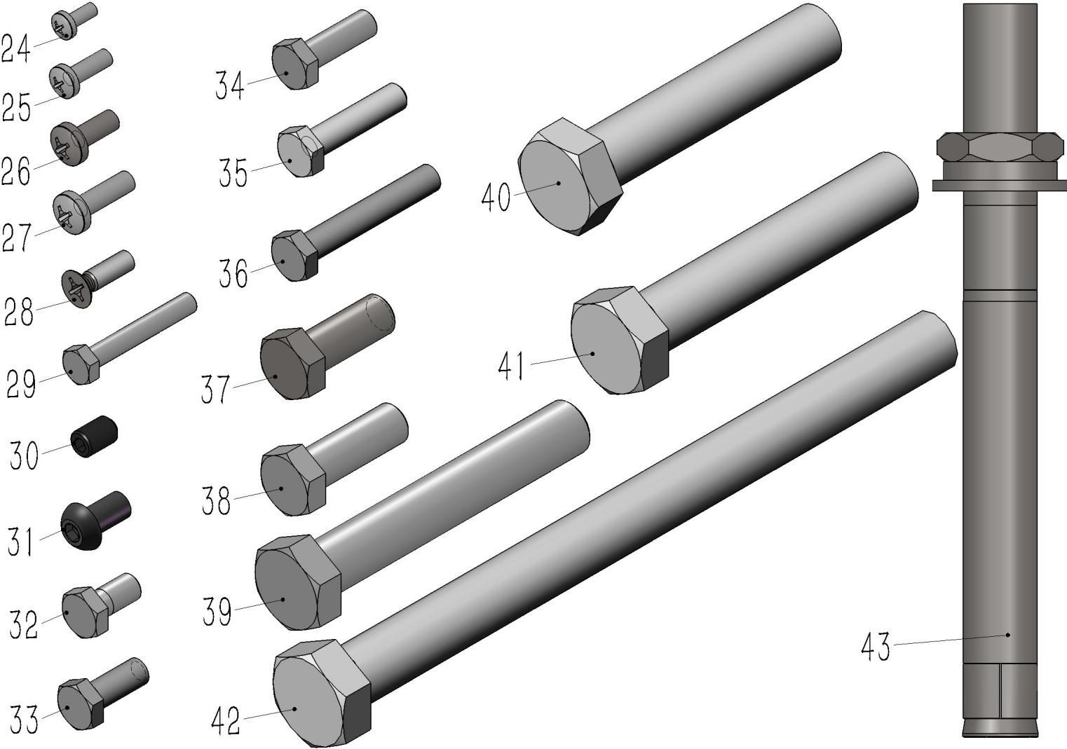

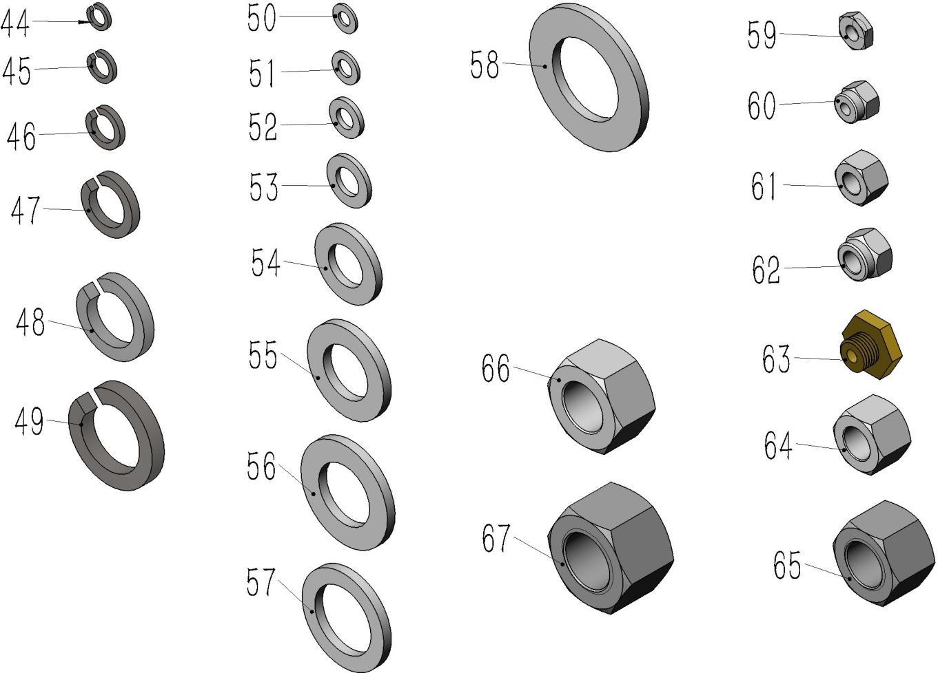

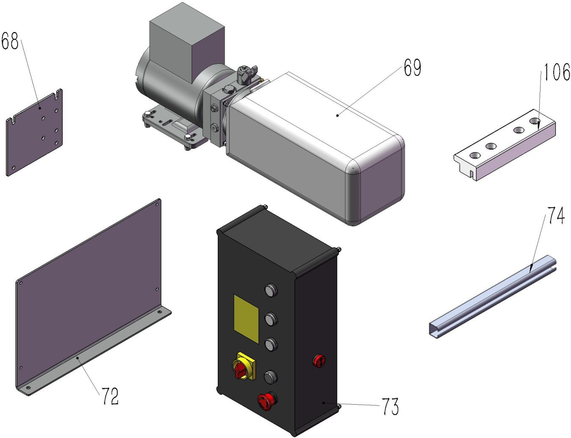

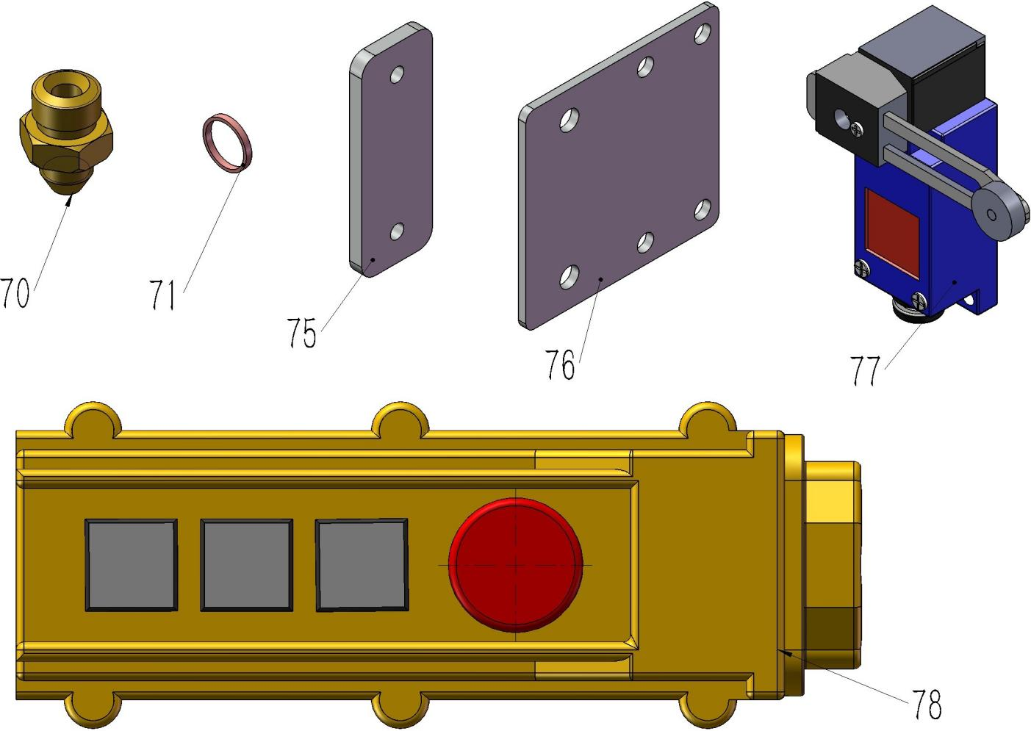

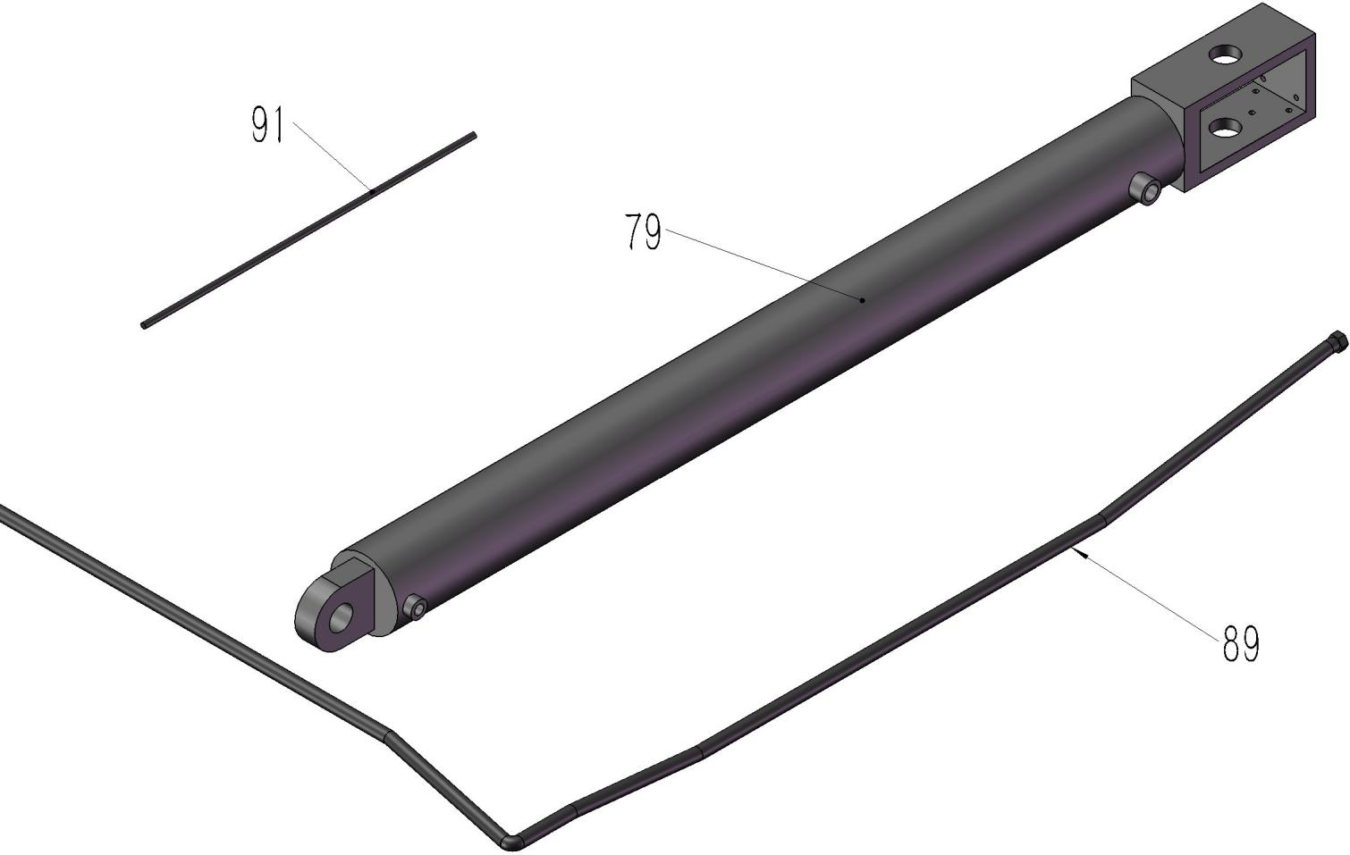

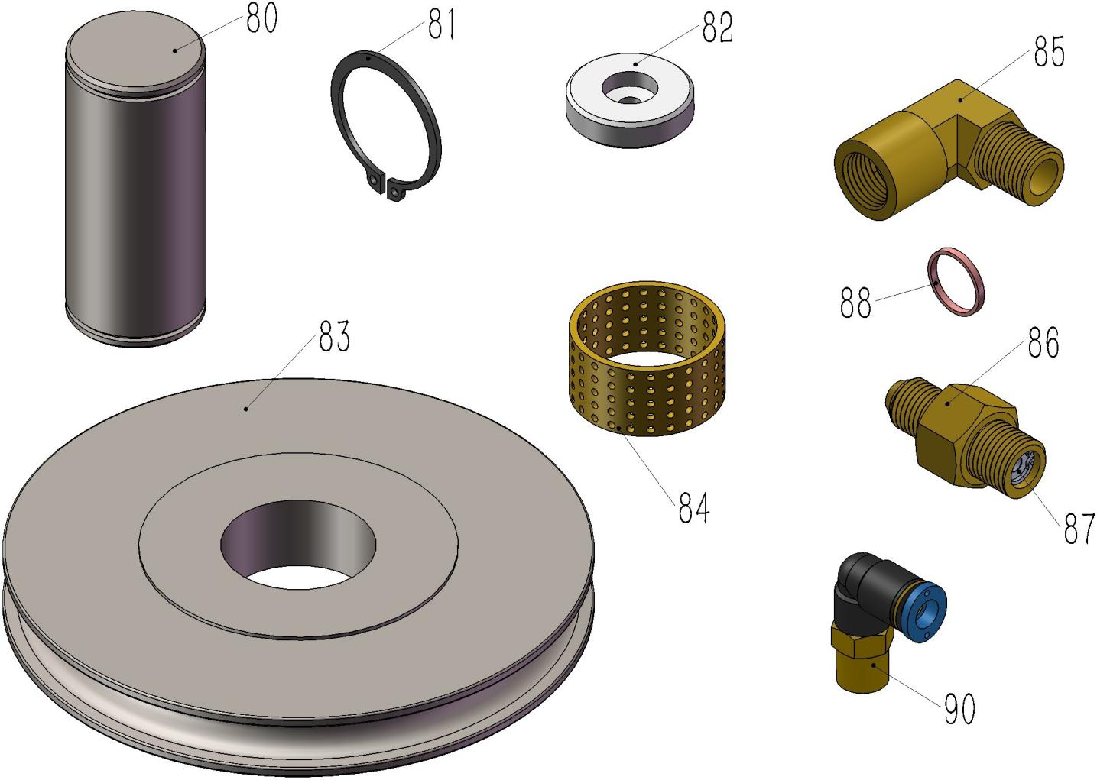

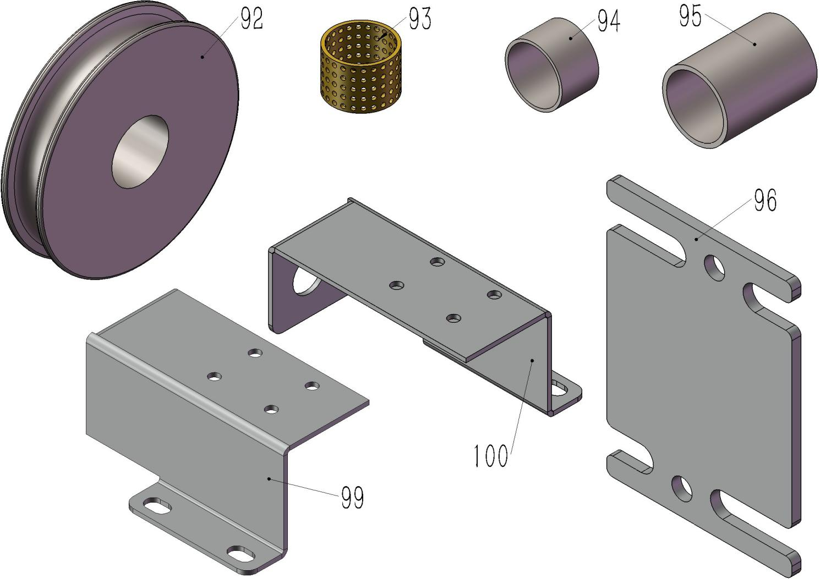

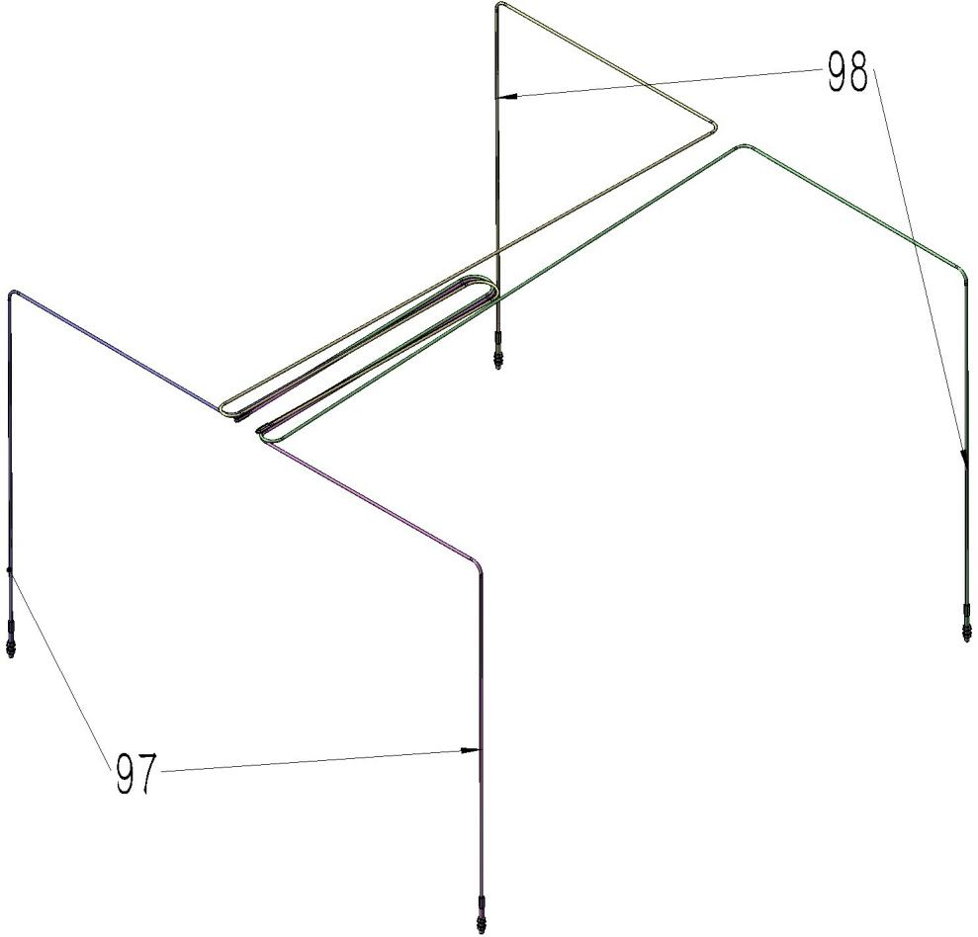

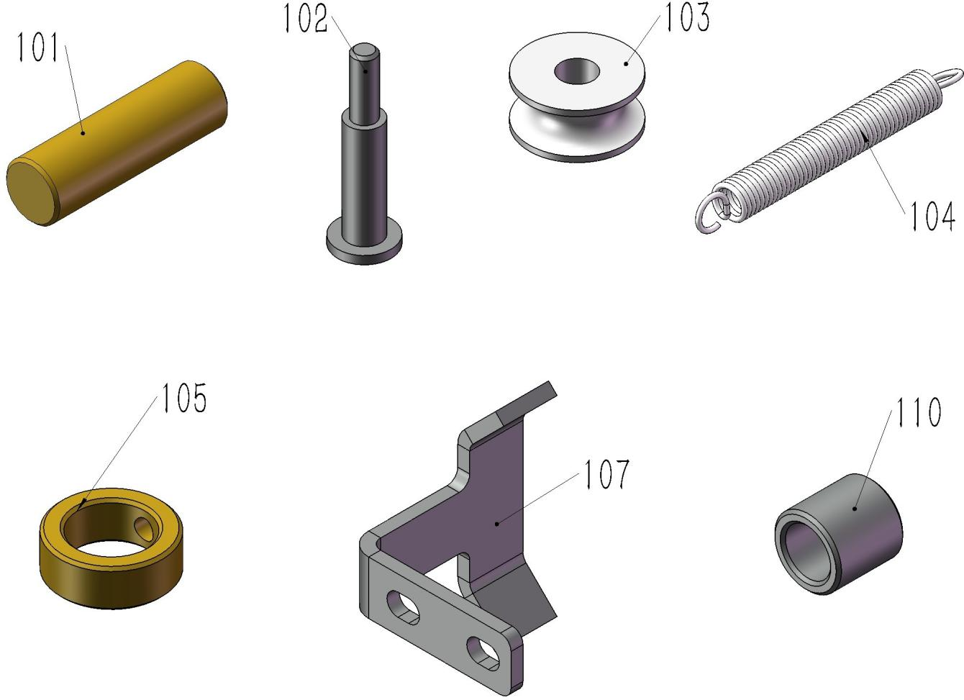

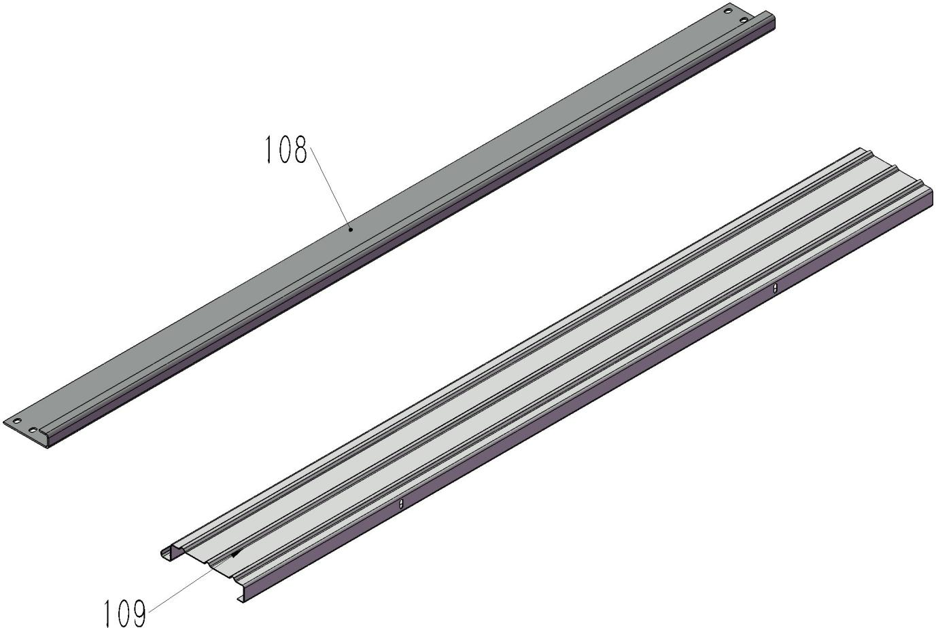

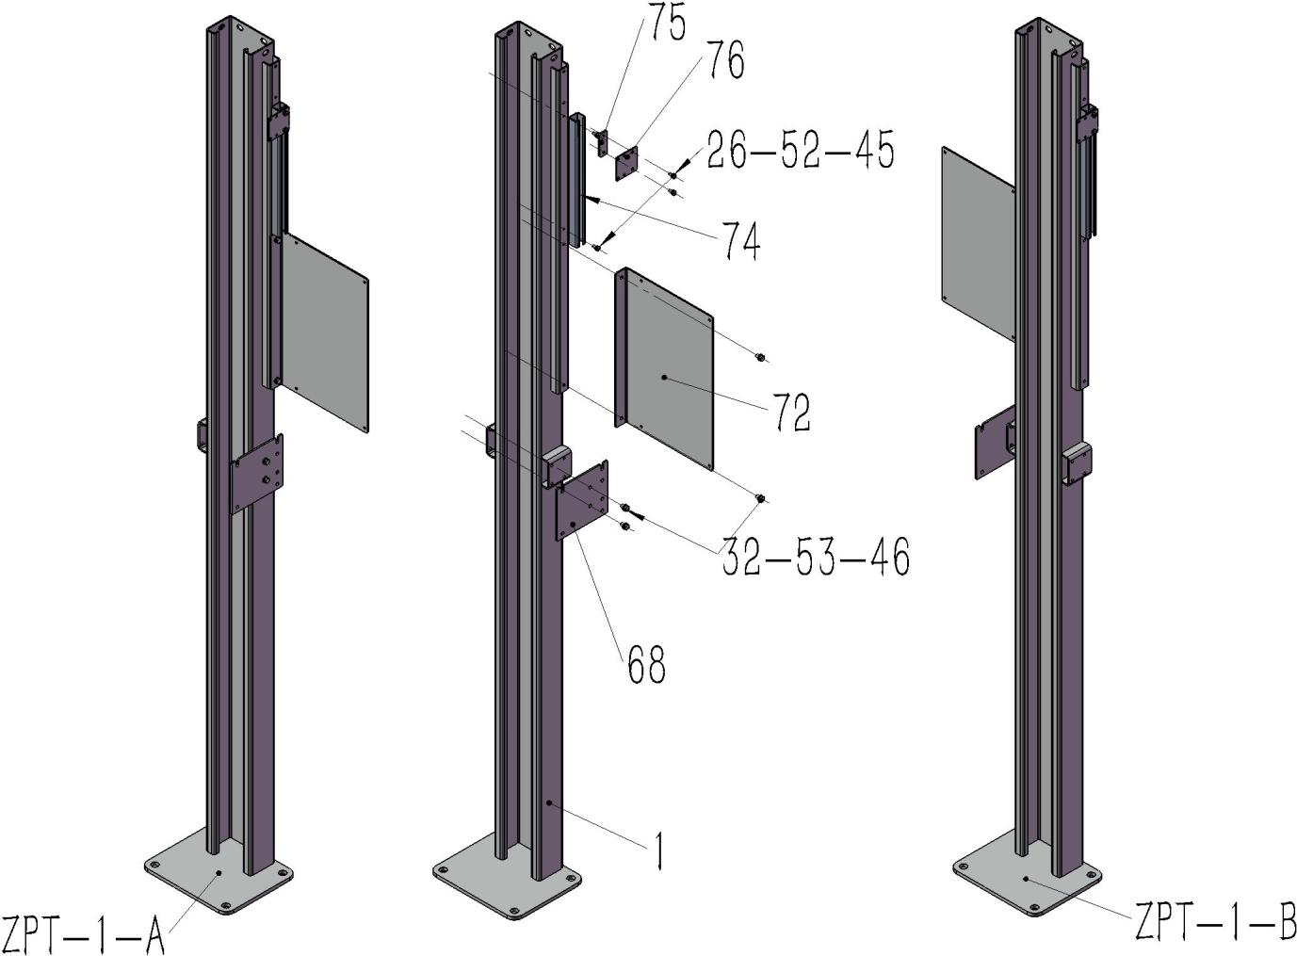

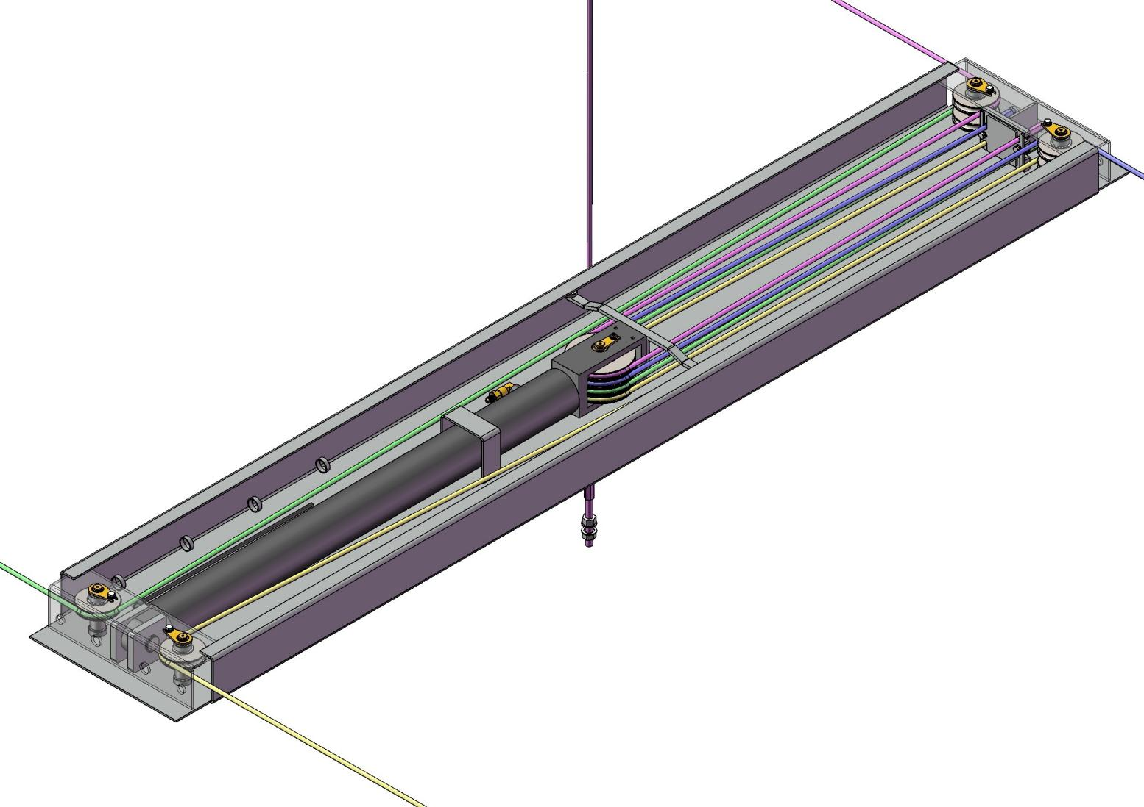

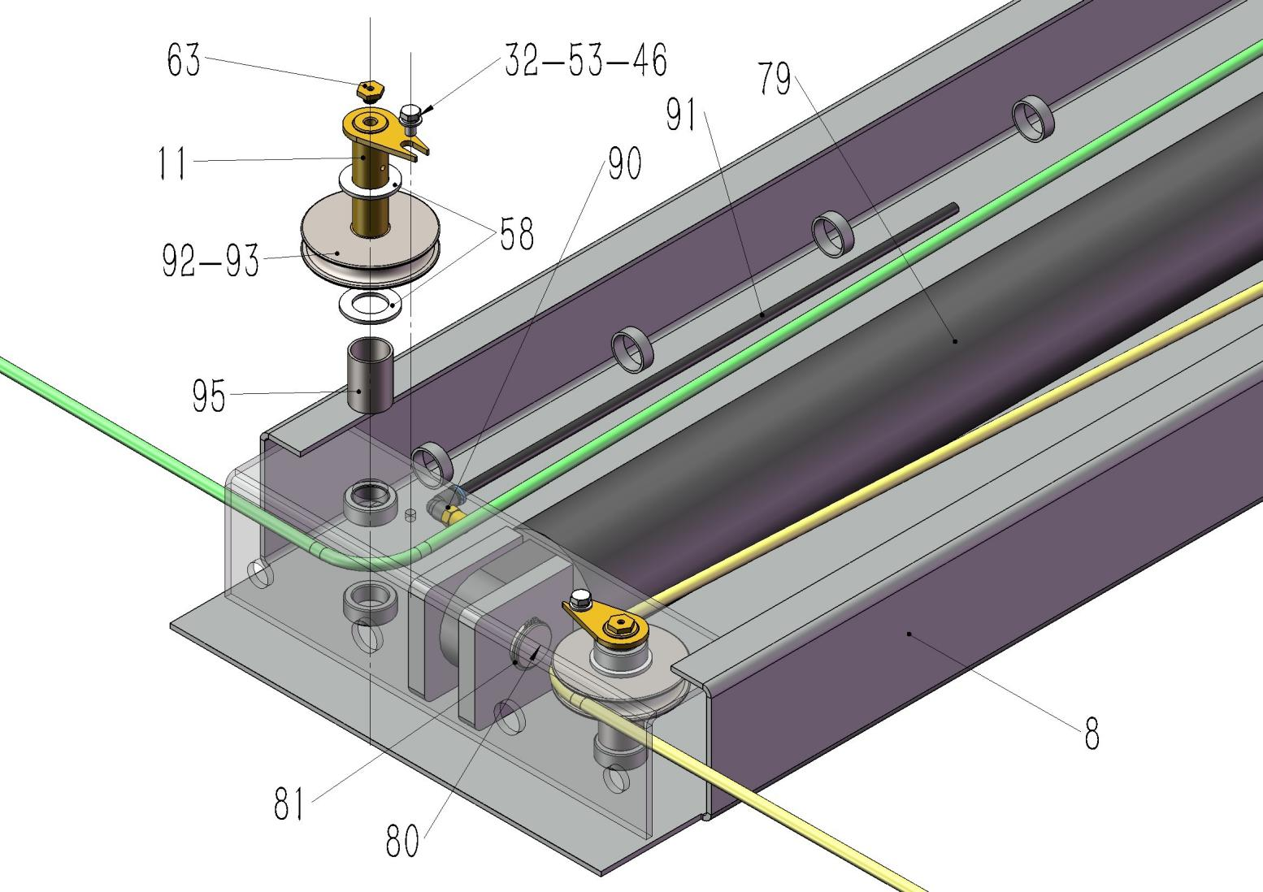

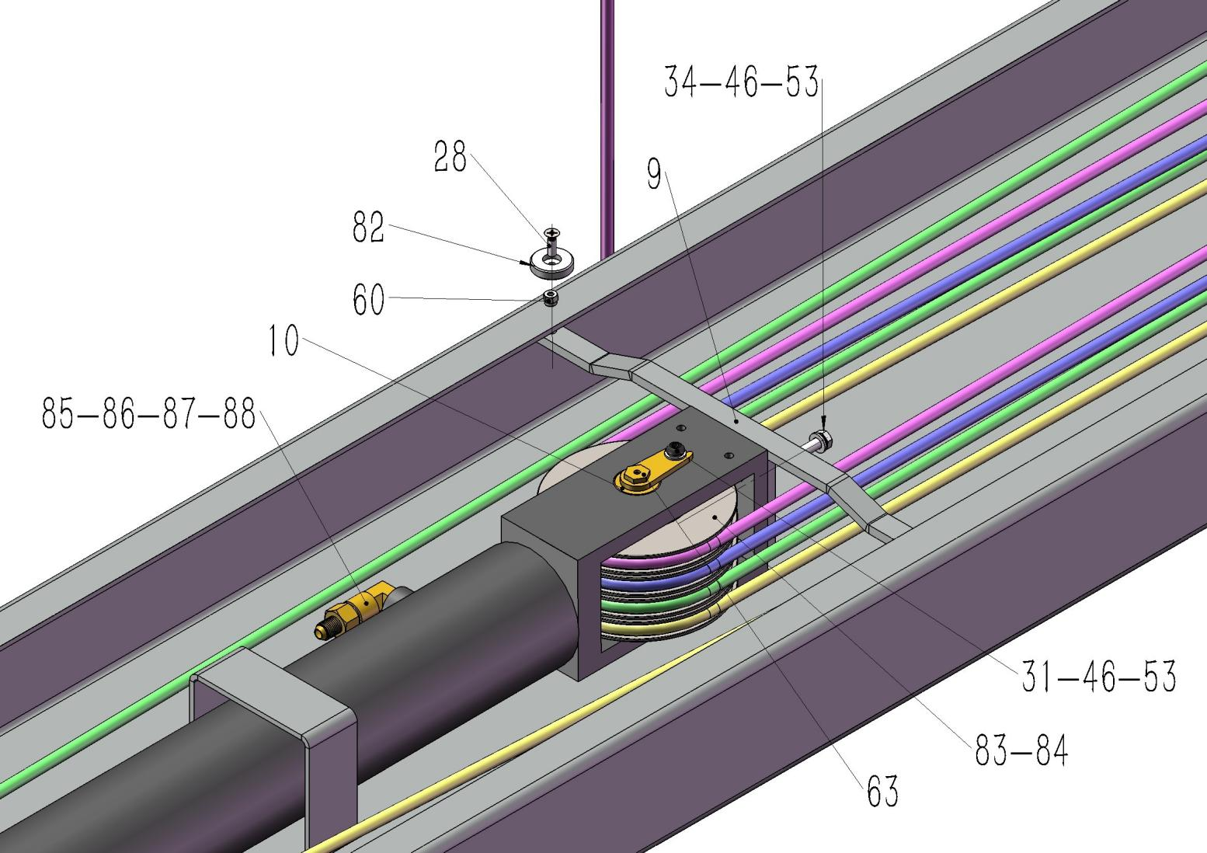

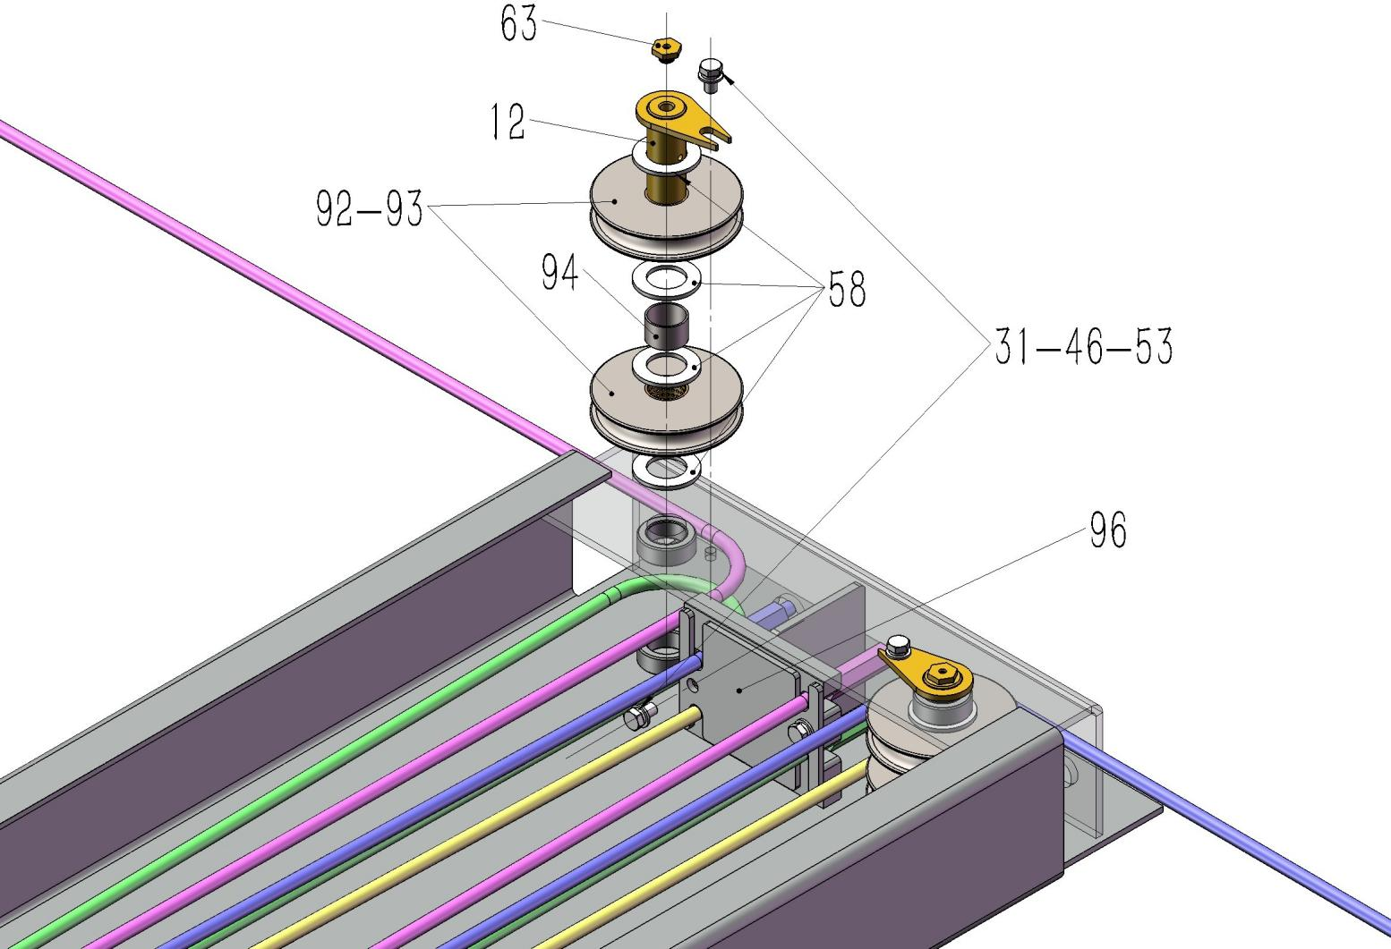

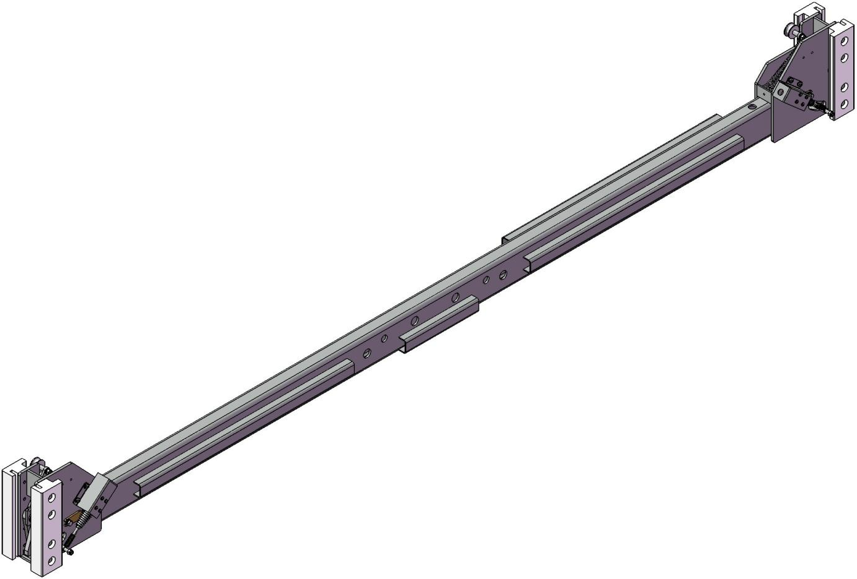

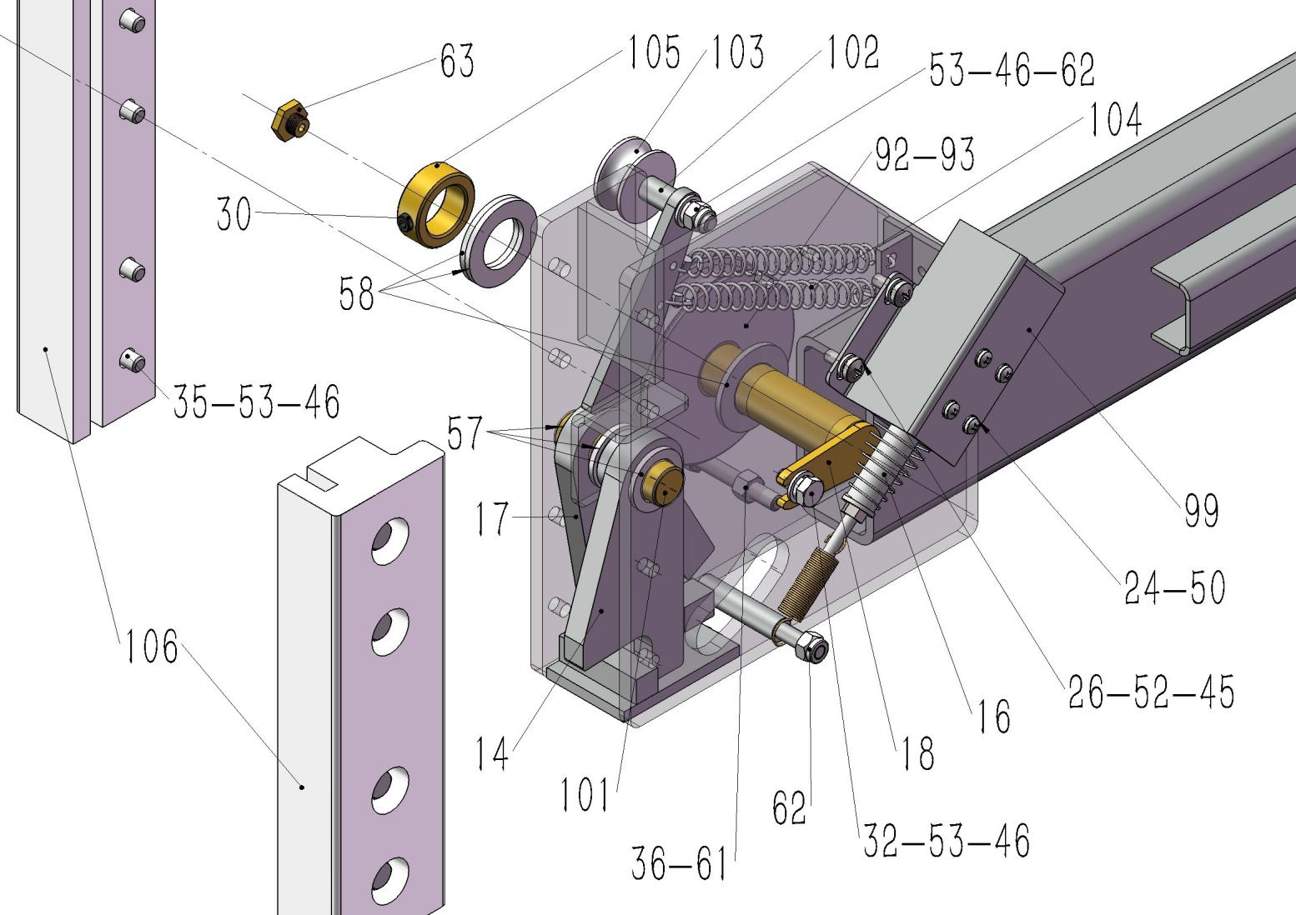

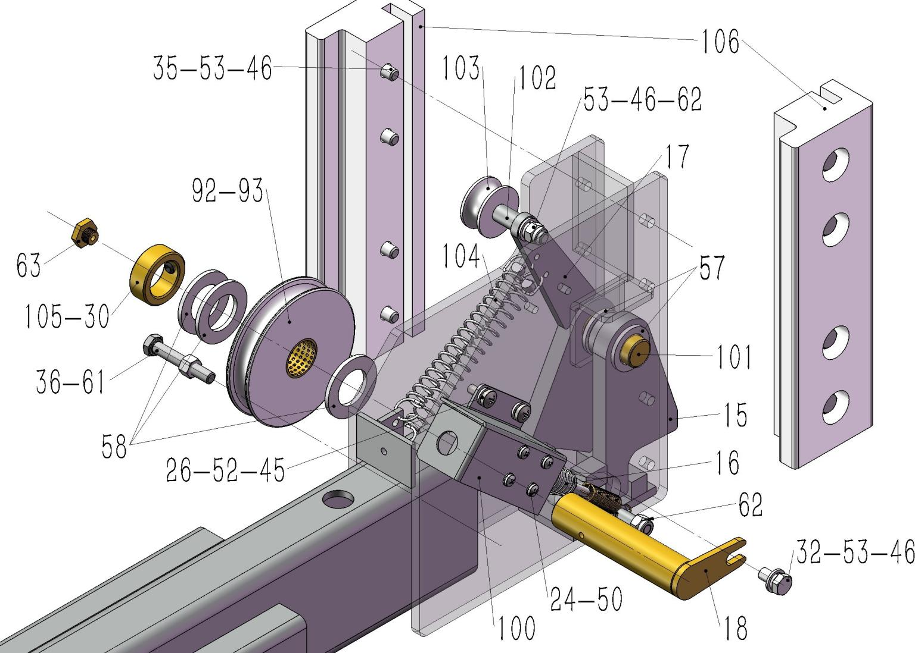

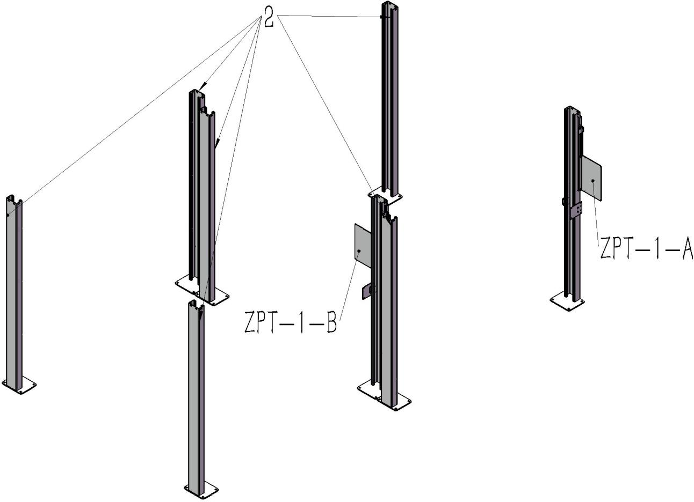

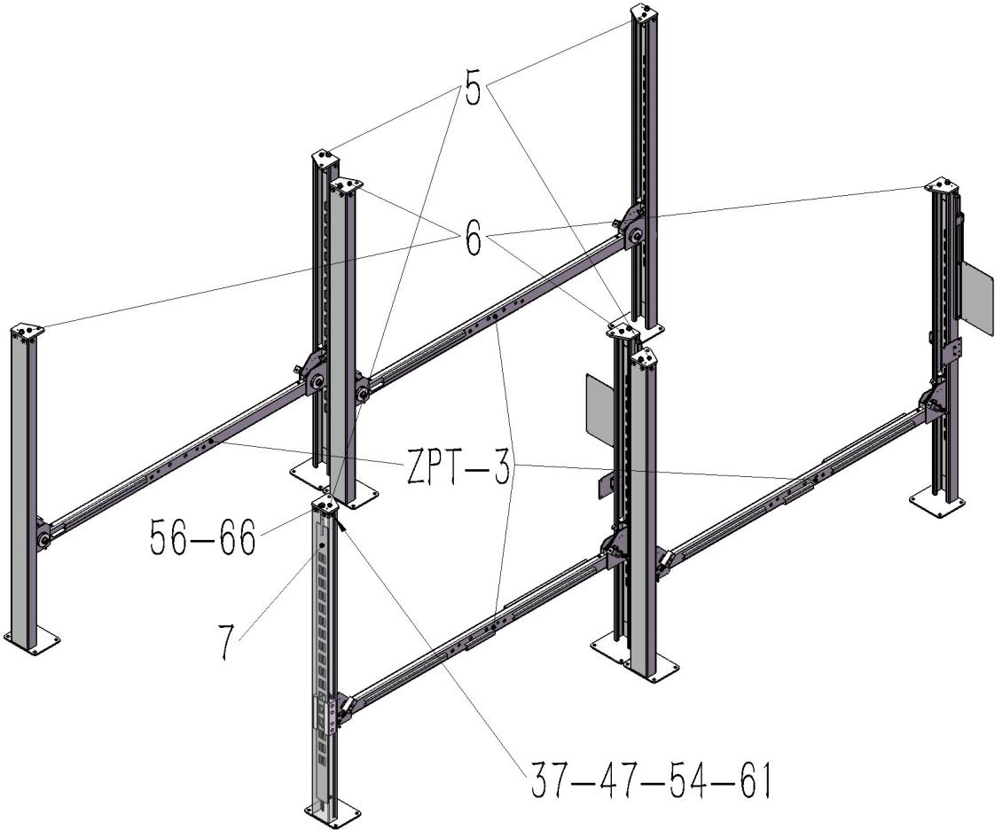

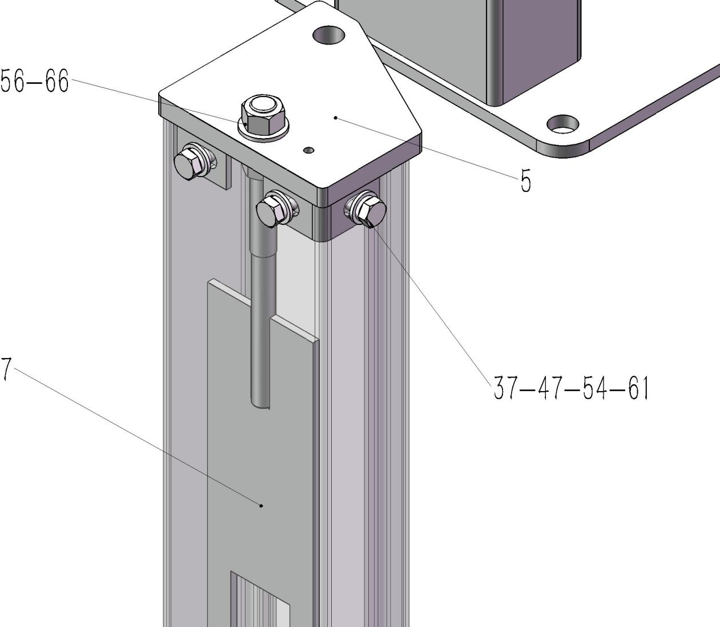

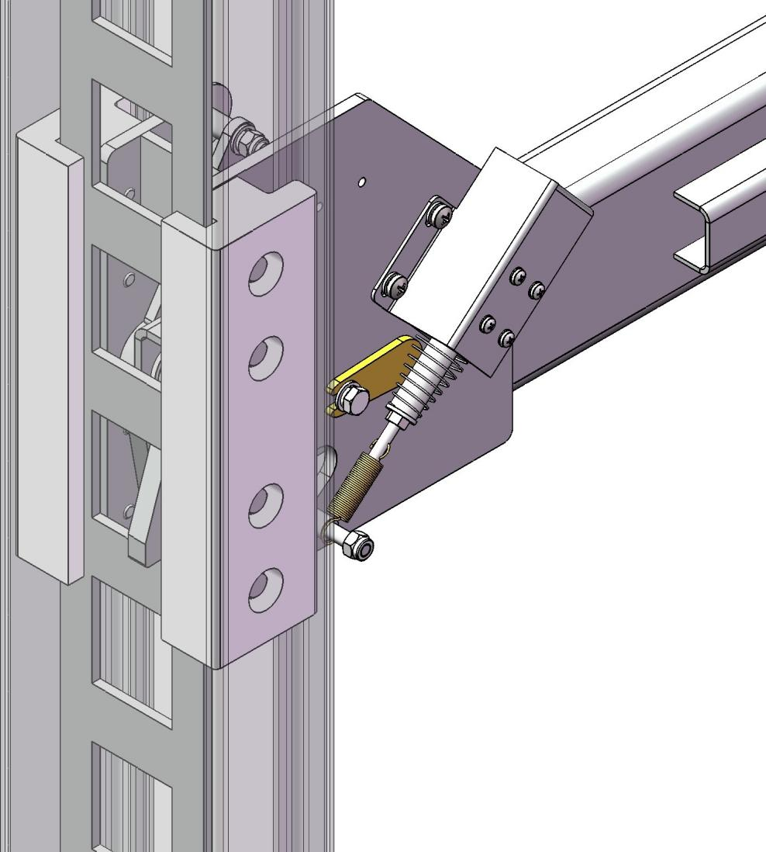

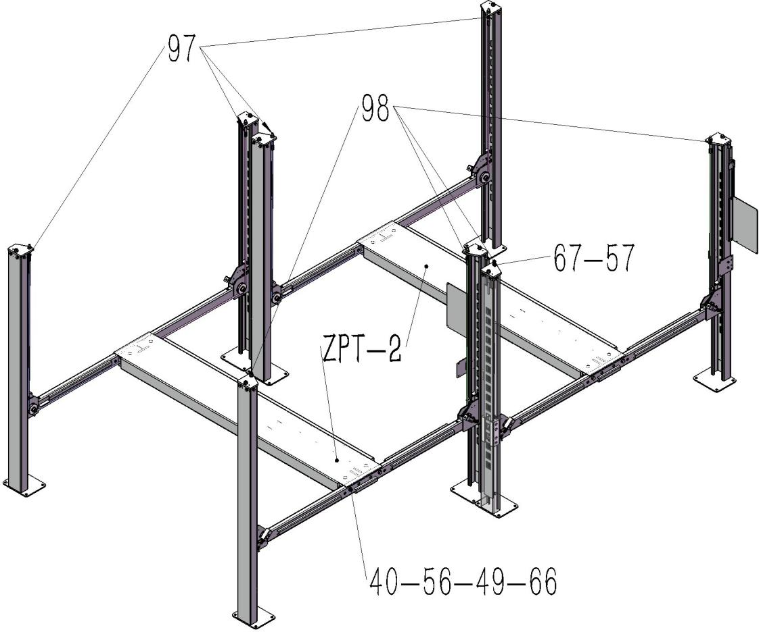

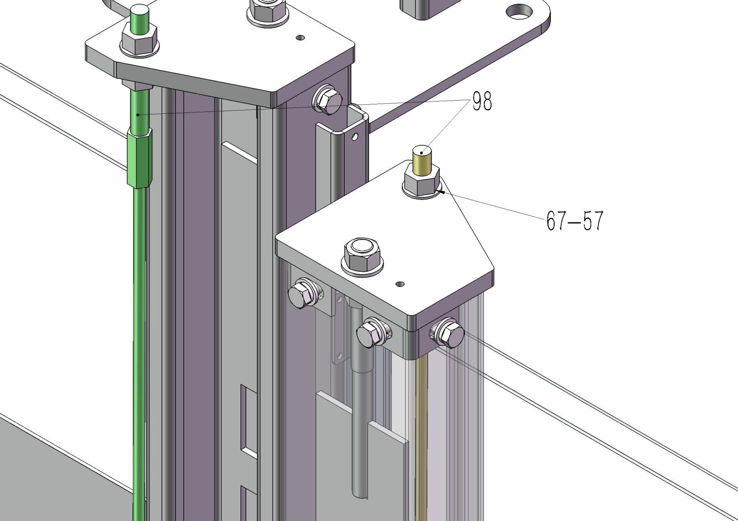

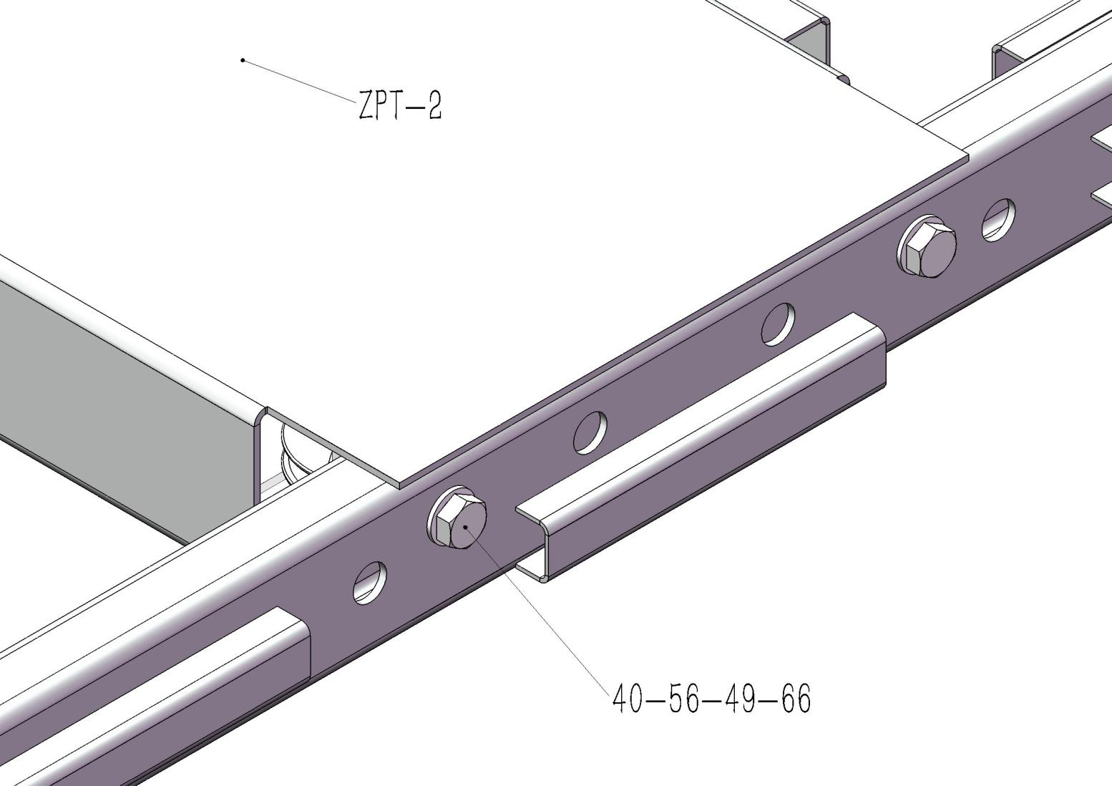

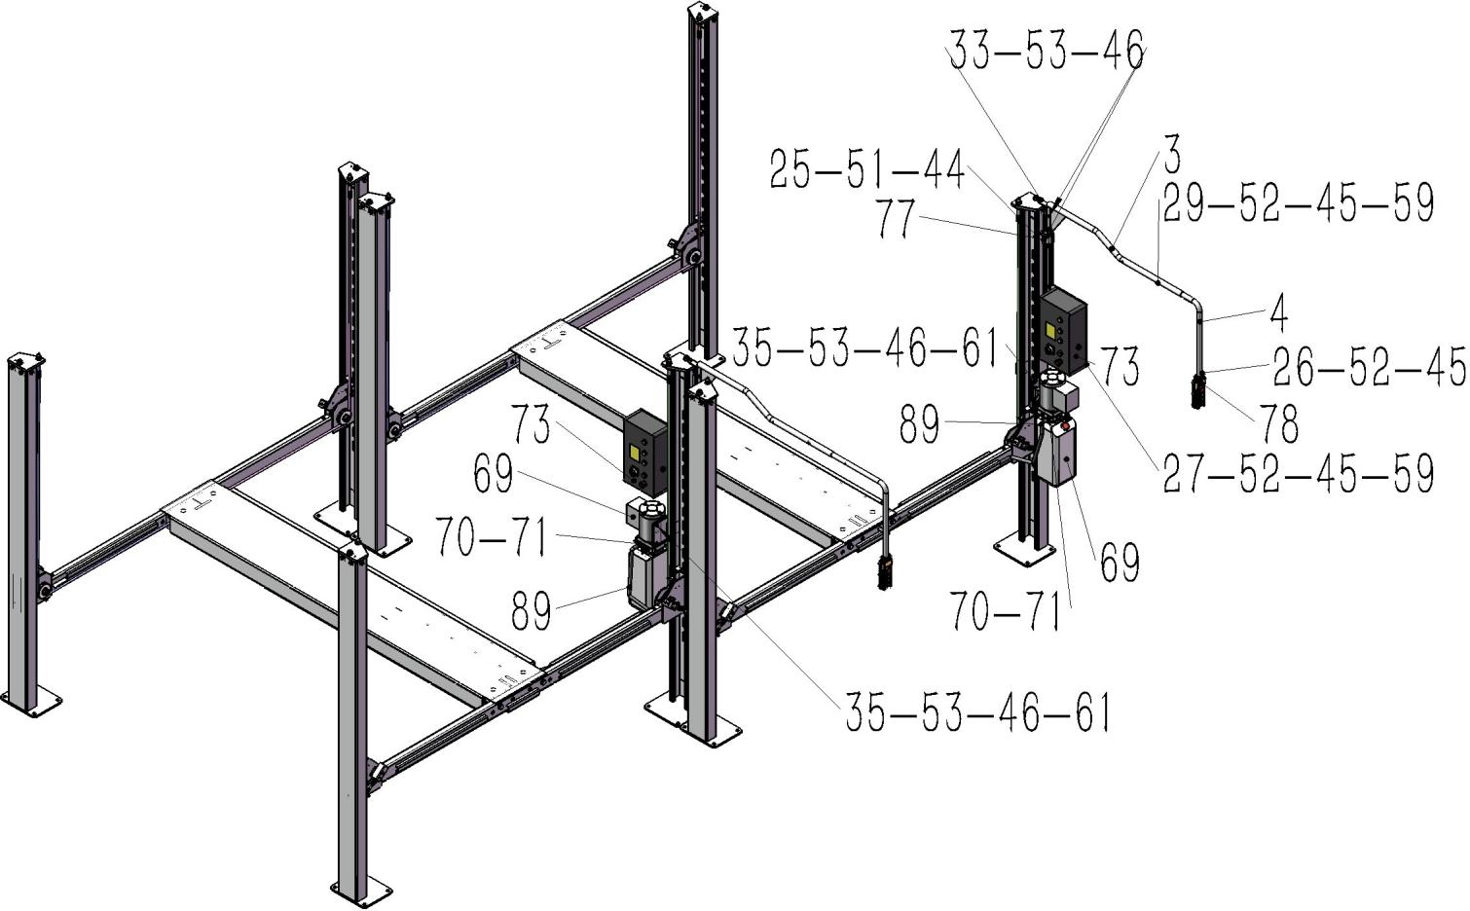

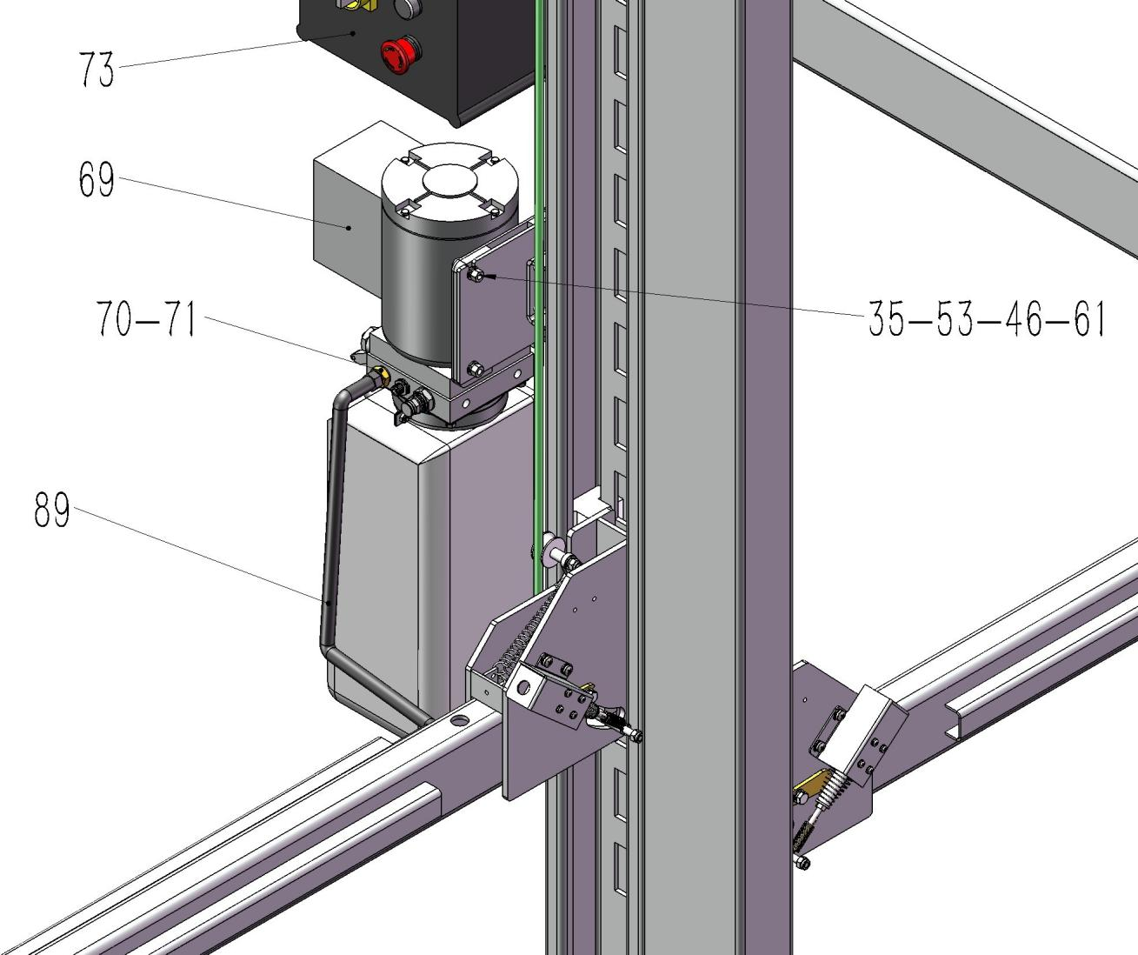

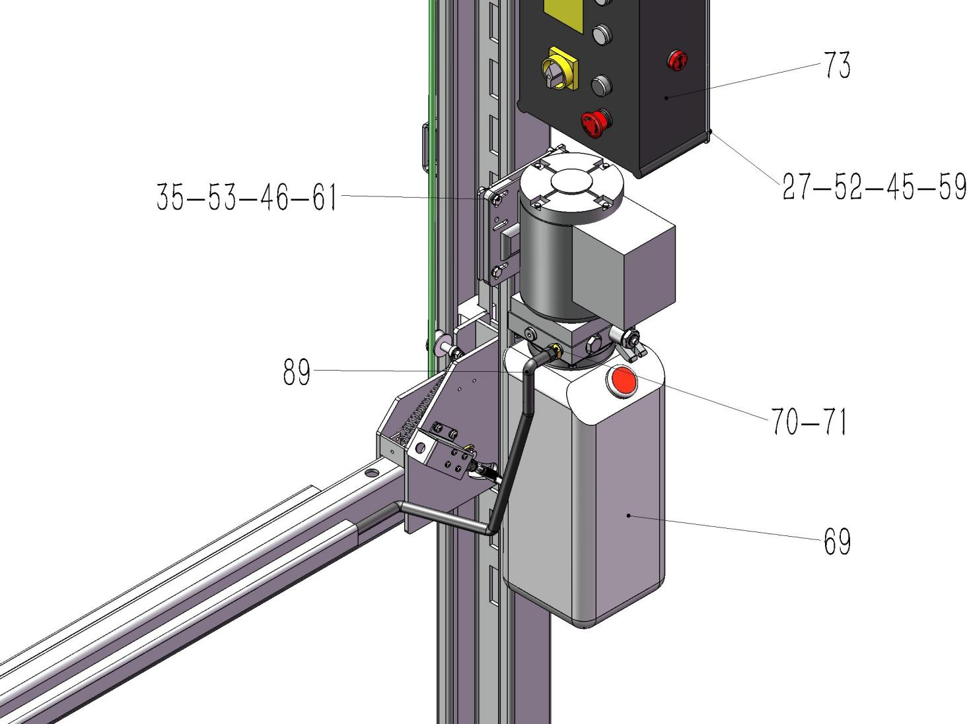

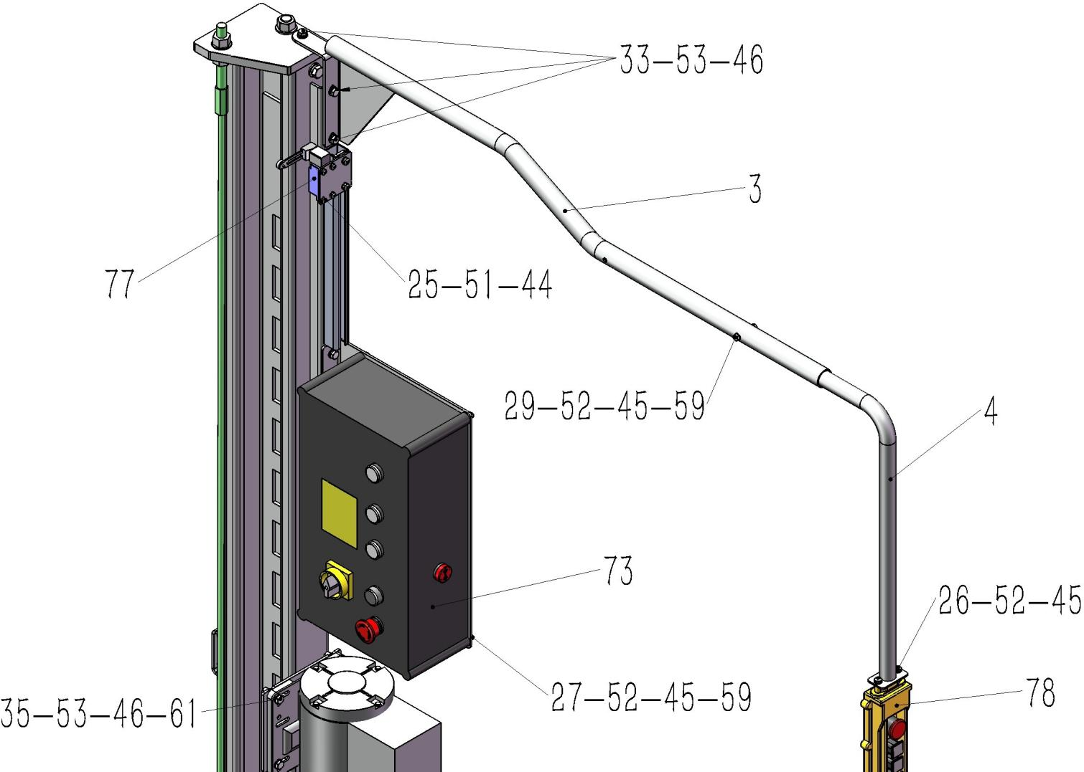

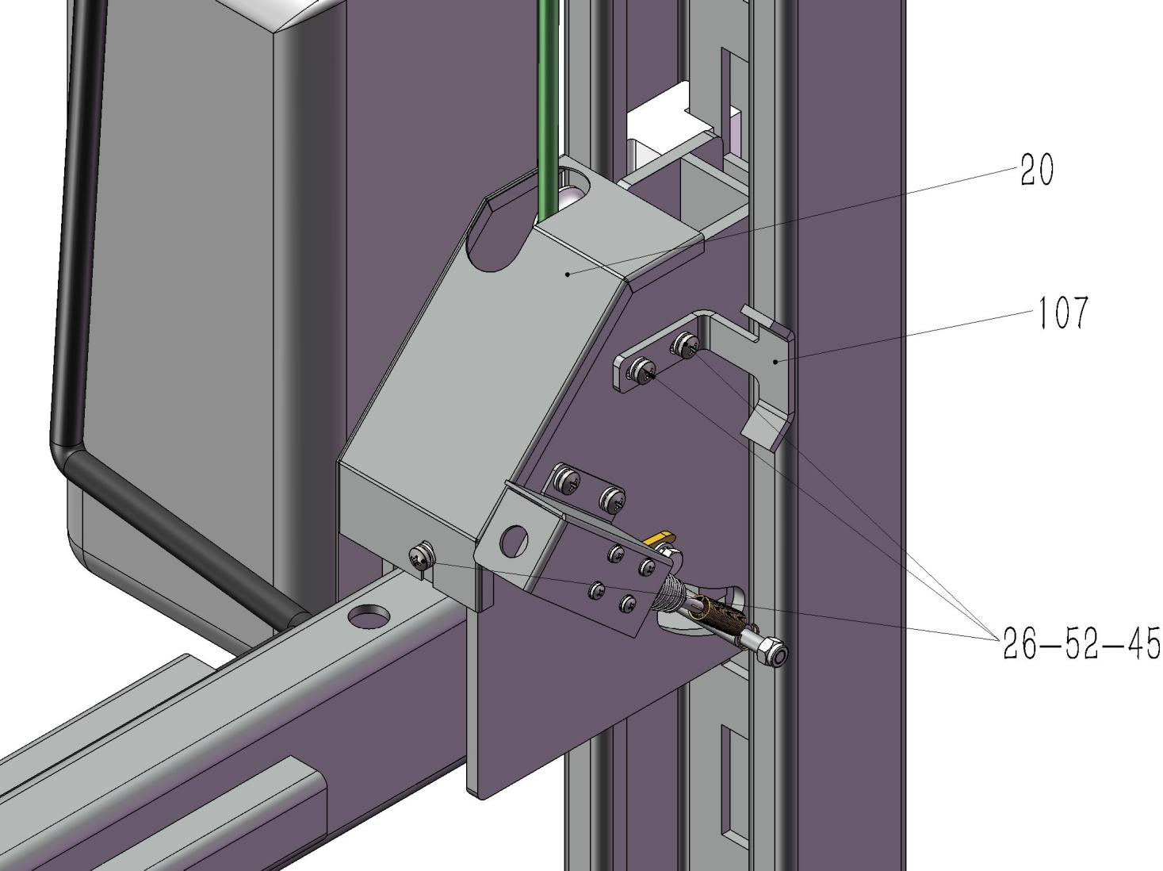

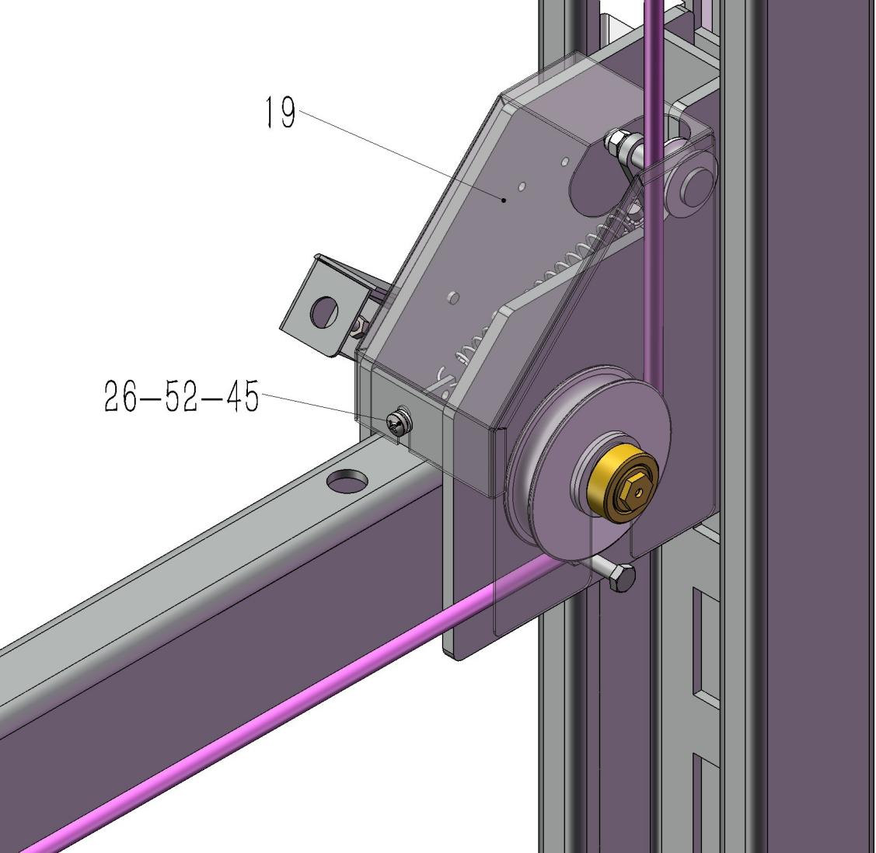

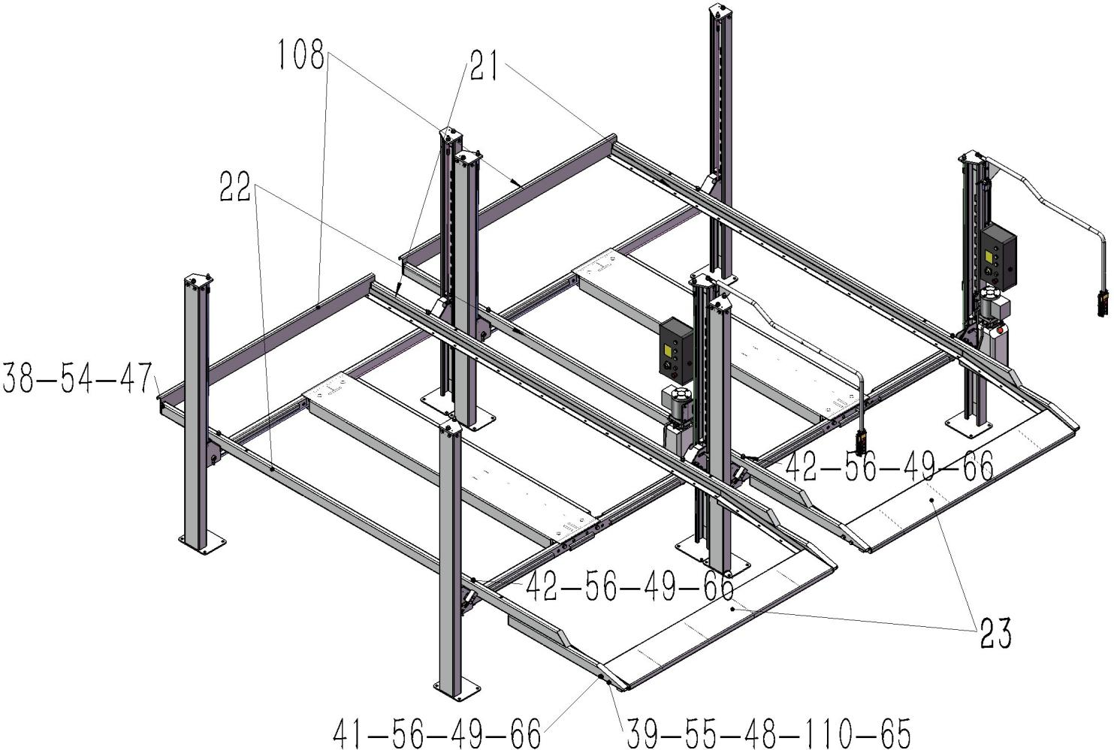

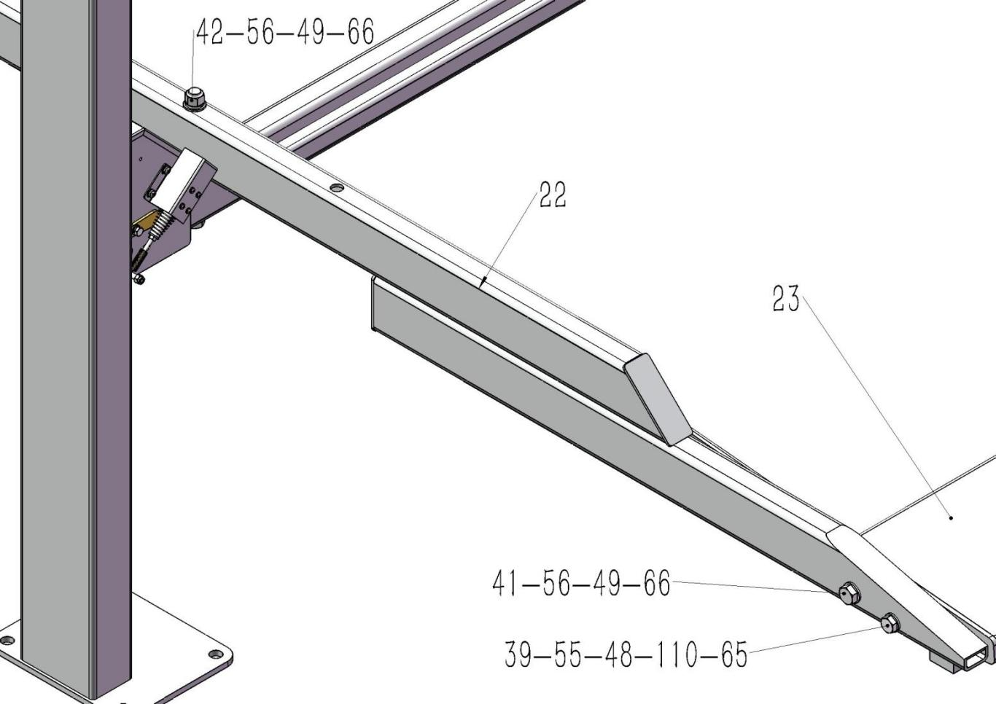

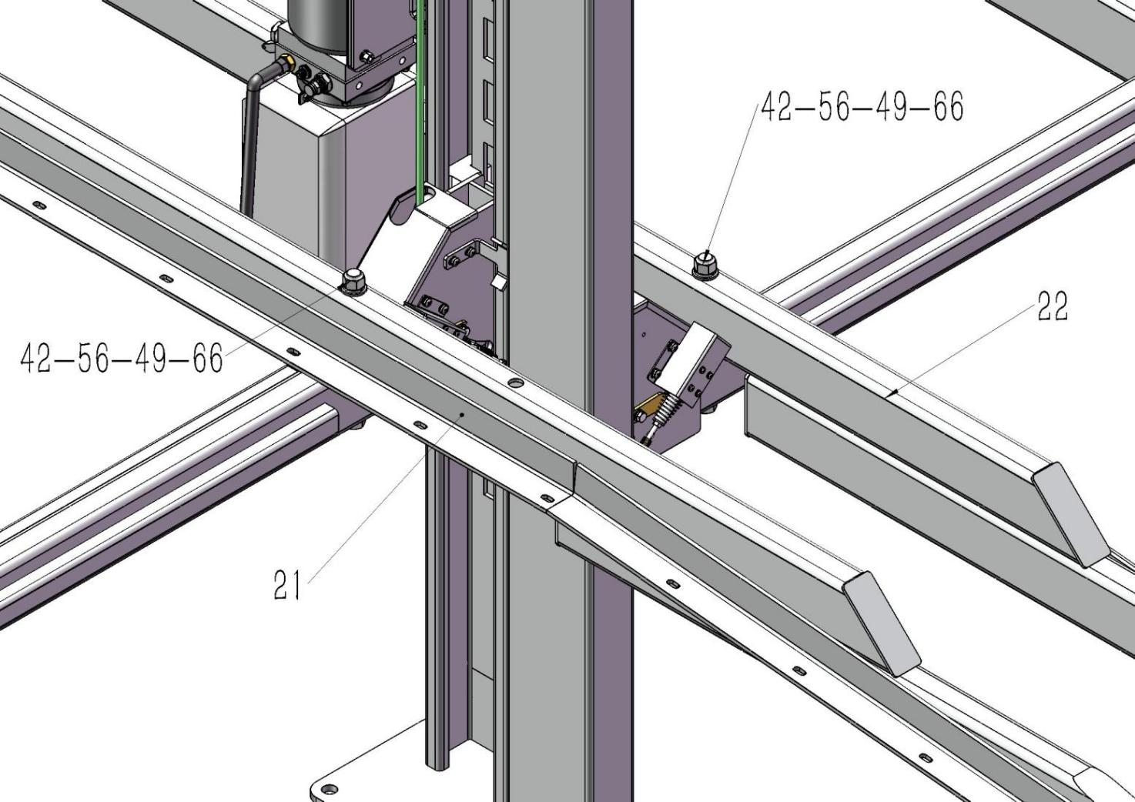

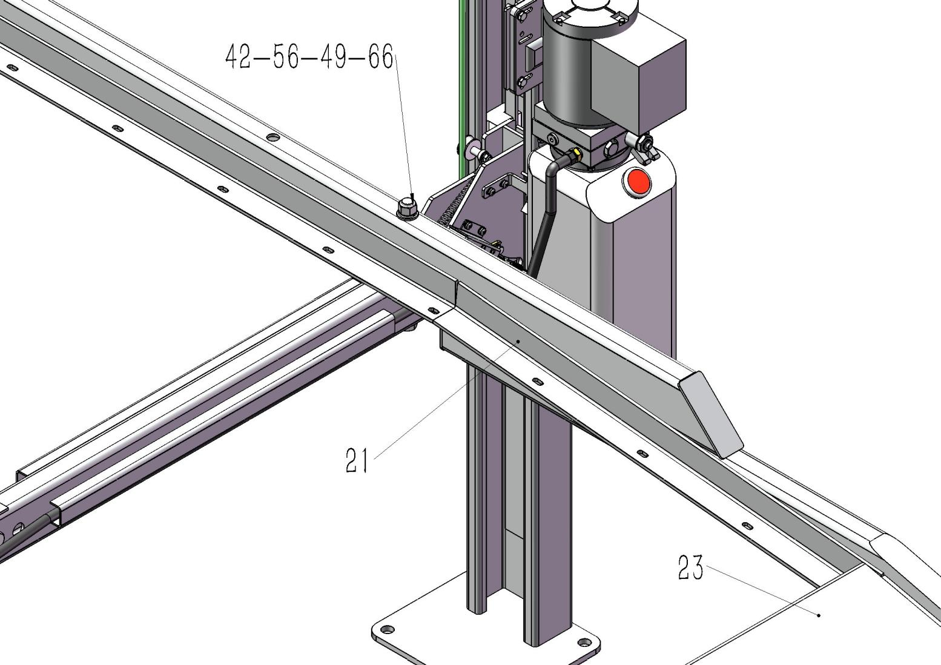

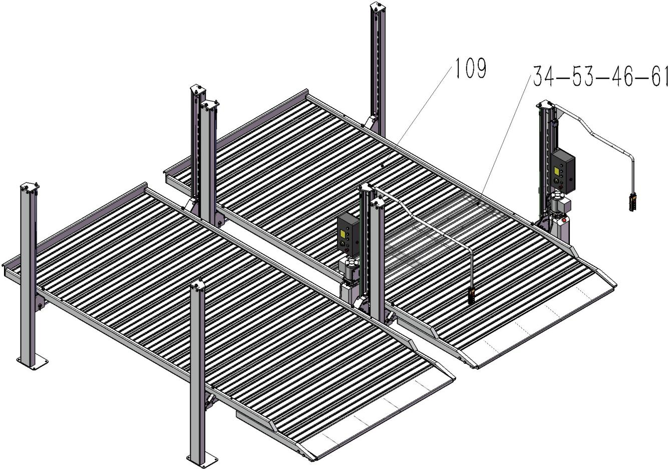

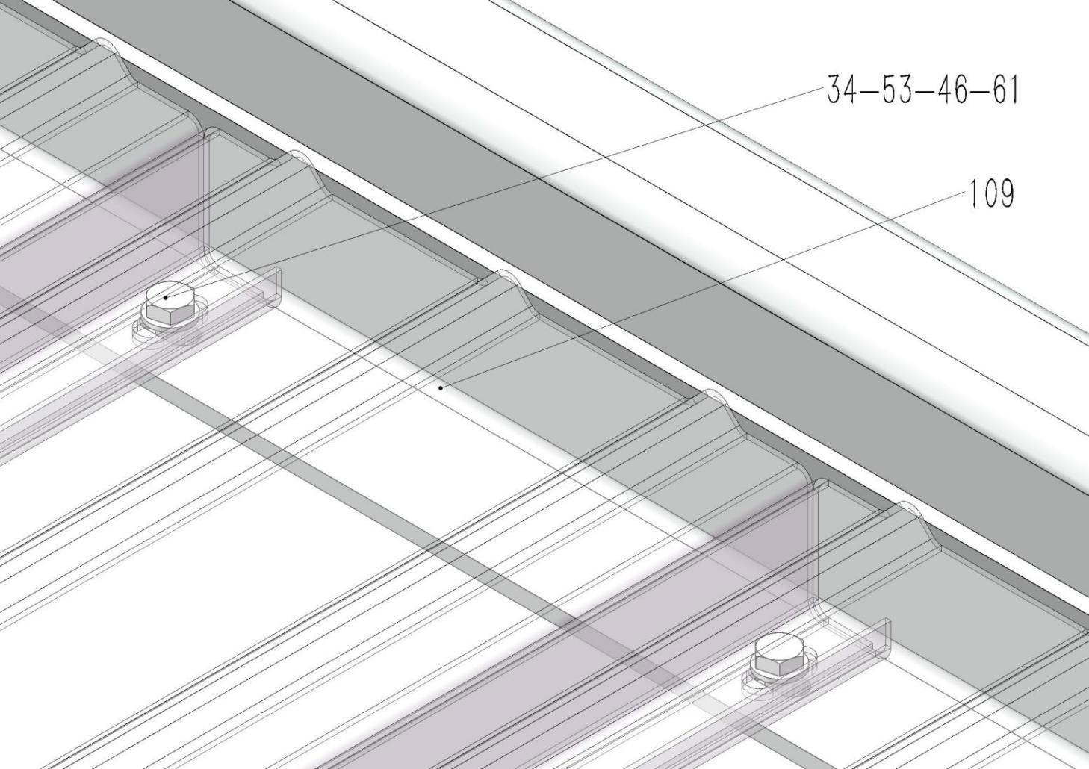

Part lift
No. | Sub.No. | Product Name | Qty/1 lift | Qty/2 lifts
Four post lift
Weld part
1 |  | Main column assembly | 1 | 2
2 |  | Sub. column assembly | 3 | 6
3 |  | Operator bar assembly | 1 | 2
4 |  | Operator bar B assembly | 1 | 2
5 |  | Top cover assembly-left | 2 | 4
6 |  | Top cover assembly-right | 2 | 4
7 |  | Lock ladder assembly | 4 | 8
8 |  | Platform assembly | 1 | 2
9 |  | Cylinder slider support assembly | 1 | 2
10 |  | Cylinder multiplying wheel assembly | 1 | 2
11 |  | Main platform A pulley axle assembly | 2 | 4
12 |  | Main platform B pulley axle assembly | 2 | 4
13 |  | Beam assembly | 2 | 4
14 |  | Left manual safety hook | 2 | 4
15 |  | Right manual safety hook | 2 | 4
16 |  | Electromagnet assembly | 2 | 4
17 |  | Stop falling safety hook assembly | 4 | 8
18 |  | Beam pulley axle assembly | 4 | 8
19 |  | Protect cover assembly-left | 2 | 4
20 |  | Protect cover assembly-Right | 2 | 4
21 |  | Platform longitudinal beam A assembly | 1 | 2
22 |  | Platform longitudinal beam B assembly | 1 | 2
23 |  | Up ramp assembly | 1 | 2
Standard part
24 |  | M4×10 Round head bolt | 8 | 16
25 |  | M5X15 Round head bolt | 4 | 8
26 |  | M6X15 Round head bolt | 16 | 32
27 |  | M6X20Round head bolt | 4 | 8
28 |  | M6×20 Flat screw | 2 | 4

29 |  | M6X40 Bolt | 1 | 2
30 |  | M8×10 Set screw | 4 | 8
31 |  | M8X15 Hexagon socket bolt with round head | 1 | 2
32 |  | M8X15 Bolt | 14 | 28
33 |  | M8X20 Bolt | 3 | 6
34 |  | M8×25 Bolt | 44 | 88
35 |  | M8X35 Bolt | 36 | 72
36 |  | M8×50 Bolt | 4 | 8
37 |  | M12×30 Bolt | 16 | 32
38 |  | M12×35 Bolt | 4 | 8
39 |  | M16×100 Bolt | 2 | 4
40 |  | M18×80 Bolt | 4 | 8
41 |  | M18×90 Bolt | 2 | 4
42 |  | M18×230 Bolt | 4 | 8
43 |  | M19 Expansion bolt | 16 | 32
44 |  | ￠5 Spring gasket | 4 | 8
45 |  | ￠6 Spring gasket | 21 | 42
46 |  | ￠8 Spring gasket | 102 | 204
47 |  | ￠12 Spring gasket | 20 | 40
48 |  | ￠16 Spring gasket | 2 | 4
49 |  | ￠18 Spring gasket | 10 | 20
50 |  | ￠4 Flat gasket | 8 | 16
51 |  | ￠5 Flat gasket | 4 | 8
52 |  | ￠6 Flat gasket | 26 | 52
53 |  | ￠8 Flat gasket | 148 | 296
54 |  | ￠12 Flat gasket | 36 | 72
55 |  | ￠16 Flat gasket | 4 | 8
56 |  | ￠18 Flat gasket | 36 | 72
57 |  | ￠20X3 Flat gasket | 12 | 24
58 |  | ￠24X3 Flat gasket | 32 | 64
59 |  | M6 Nut | 5 | 10
60 |  | M6 Self-lock nut | 2 | 4
61 |  | M8 Nut | 8 | 16
62 |  | M8 Self-lock nut | 50 | 100
63 |  | M10 Nipple | 9 | 18

64 |  | M12 Nut | 16 | 32
65 |  | M16 Nut | 2 | 4
66 |  | M18 Nut | 26 | 52
67 |  | M20 Nut | 8 | 16
Column part
 | 1 | Main column assembly | 1 | 2
 | 2 | Sub. Column assembly | 3 | 6
68 |  | Power unit mounting plate | 1 | 2
 | 32 | M8X15 Bolt | 2 | 4
 | 53 | ￠8 Flat gasket | 2 | 4
 | 46 | ￠8 Spring gasket | 2 | 4
69 |  | Power unit | 1 | 2
70 |  | 9/16 point power unit connectors | 1 | 2
71 |  | ￠14Copper gasket | 1 | 2
 | 35 | M8X35 Bolt | 4 | 8
 | 53 | ￠8 Flat gasket | 8 | 16
 | 46 | ￠8 Spring gasket | 4 | 8
 | 61 | M8 Nut | 4 | 8
72 |  | Control box bracket | 1 | 2
 | 32 | M8X15 Bolt | 2 | 4
 | 53 | ￠8 Flat gasket | 2 | 4
 | 46 | ￠8 Spring gasket | 2 | 4
73 |  | Big control box | 1 | 2
 | 27 | M6X20 Round head bolt | 4 | 8
 | 52 | ￠6 Flat gasket | 4 | 8
 | 45 | ￠6 Spring gasket | 4 | 8
 | 59 | M6 Nut | 4 | 8
74 |  | Up limit switch sliding rail | 1 | 2
 | 26 | M6X15 Round head bolt | 2 | 4
 | 52 | ￠6 Flat gasket | 2 | 4
 | 45 | ￠6 Spring gasket | 2 | 4
75 |  | Up limit switch fix plate | 1 | 2
76 |  | Up limit switch mounting plate | 1 | 2

 | 26 | M6X15 Round head bolt | 2 | 4
 | 52 | ￠6 Flat gasket | 2 | 4
 | 45 | ￠6 Spring gasket | 2 | 4
77 |  | Travel switch | 1 | 2
 | 25 | M5X15 Round head bolt | 4 | 8
 | 51 | ￠5 Flat gasket | 4 | 8
 | 44 | ￠5 Spring gasket | 4 | 8
 | 3 | Operator bar assembly | 1 | 2
 | 33 | M8X20 Bolt | 3 | 6
 | 53 | ￠8 Flat gasket | 3 | 6
 | 46 | ￠8 Spring gasket | 3 | 6
 | 4 | Operator bar B assembly | 1 | 2
 | 29 | M6X40 Bolt | 1 | 2
 | 52 | ￠6 Flat gasket | 2 | 4
 | 45 | ￠6 Spring gasket | 1 | 2
 | 59 | M6 Nut | 1 | 2
78 |  | Button box | 1 | 2
 | 26 | M6X15 Round head bolt | 2 | 4
 | 52 | ￠6 Flat gasket | 2 | 4
 | 45 | ￠6 Spring gasket | 2 | 4
 | 5 | Left top cover assembly | 2 | 4
 | 6 | Right top cover assembly | 2 | 4
 | 37 | M12×30 Bolt | 16 | 32
 | 47 | ￠12 Spring gasket | 16 | 32
 | 54 | ￠12 Flat gasket | 32 | 64
 | 64 | M12 Nut | 16 | 32
 | 7 | Lock ladder assembly | 4 | 8
 | 56 | ￠18 Flat gasket | 16 | 32
 | 66 | M18 Nut | 16 | 32
 | 43 | M19 Expansion anchor bolt | 16 | 32
Platform part
 | 8 | Platform assembly | 1 | 2
79 |  | Cylinder | 1 | 2
80 |  | Cylinder shaft | 1 | 2

81 |  | ￠35 Outside spring | 2 | 4
 | 9 | Cylinder slider bracket assembly | 1 | 2
 | 34 | M8×25 Bolt | 2 | 4
 | 46 | ￠8 Spring gasket | 2 | 4
 | 53 | ￠8 Flat gasket | 2 | 4
82 |  | ￠32/￠9X8mm Nylon slider | 2 | 4
 | 28 | M6×20 Flat screw | 2 | 4
 | 60 | M6 Self-lock nut | 2 | 4
83 |  | Multiplying wheel | 4 | 8
84 |  | Oilless bearing-35 | 4 | 8
 | 10 | Cylinder multiplying wheel axle assembly | 1 | 2
 | 63 | M10 Nipple | 1 | 2
 | 31 | M8X15 Hexagon socket bolt with round head | 1 | 2
 | 46 | ￠8 Spring gasket | 1 | 2
 | 53 | ￠8 Flat gasket | 1 | 2
85 |  | 90 degree ZG3/8 connector | 1 | 2
86 |  | ZG3/8 Explosion valve | 1 | 2
87 |  | 9/16 point connector | 1 | 2
88 |  | ￠16 copper pad | 2 | 4
89 |  | Oil tube （L=3580mm） | 1 | 2
90 |  | 1/4 Oil return pipe straight connector | 1 | 2
91 |  | Air tube | 1 | 2
92 |  | Pulley | 6 | 12
93 |  | Oilless bearing-25 | 6 | 12
 | 58 | ￠24X3 Flat gasket | 12 | 24
94 |  | 1inch galvanized pipe×18 | 2 | 4
95 |  | 1 inch galvanized pipe×44 | 2 | 4
 | 11 | Main platform A pulley axle assembly | 2 | 4
 | 12 | Main Platform B pulley axle assembly | 2 | 4
 | 63 | M10 Nipple | 4 | 8
96 |  | Main platform cable lock plate | 1 | 2
 | 32 | M8X15 Bolt | 6 | 12
 | 53 | ￠8 Flat gasket | 6 | 12
 | 46 | ￠8 Spring gasket | 6 | 12
97 |  | Cable ￠9.53，L=4215 | 2 | 4

98 |  | Cable ￠9.53，L=6936 | 2 | 4
 | 67 | M20 Nut | 8 | 16
 | 57 | ￠20X3 Flat gasket | 8 | 16
 | 40 | M18×80 Bolt | 4 | 8
 | 56 | ￠18 Flat gasket | 8 | 16
 | 49 | ￠18 Spring gasket | 4 | 8
 | 66 | M18 Nut | 4 | 8
Beam part
 | 13 | Beam assembly | 2 | 4
 | 14 | Left manual safety hook | 2 | 4
 | 15 | Right manual safety hook | 2 | 4
 | 16 | Electromagnet assembly | 2 | 4
 | 24 | M4×10 Round head bolt | 8 | 16
 | 50 | ￠4 Flat gasket | 8 | 16
99 |  | Electromagnet bracket A | 1 | 2
100 |  | Electromagnet bracket B | 1 | 2
 | 26 | M6×15 Round head bolt | 4 | 8
 | 52 | ￠6 Flat gasket | 4 | 8
 | 45 | ￠6 Spring gasket | 4 | 8
 | 62 | M8 Self-lock nut | 4 | 8
101 |  | Beam safety axle | 4 | 8
 | 57 | ￠20X3 Flat gasket | 12 | 24
 | 17 | Stop falling safety hook assembly | 4 | 8
102 |  | Stop falling safety hook limit wheel pin | 4 | 8
103 |  | Stop fulling safety hook limit wheel | 4 | 8
 | 53 | ￠8 Flat gasket | 4 | 8
 | 46 | ￠8 Spring gasket | 4 | 8
 | 62 | M8 Self-lock nut | 4 | 8
104 |  | Tension spring（￠1.6×￠12 ×72） | 8 | 16
 | 18 | Beam cable pulley axle assembly | 4 | 8
 | 32 | M8X15 Bolt | 4 | 8
 | 53 | ￠8 Flat gasket | 4 | 8
 | 46 | ￠8 Spring gasket | 4 | 8
 | 58 | ￠24X3 Flat gasket | 12 | 24

 | 92 | Pulley | 4 | 8
 | 93 | Oilless bearing-25 | 4 | 8
105 |  | Beam pulley spacer | 4 | 8
 | 30 | M8×10 Set screw | 4 | 8
 | 63 | M10 Nipple | 4 | 8
 | 36 | M8×50 Bolt | 4 | 8
 | 61 | M8 Nut | 4 | 8
106 |  | Beam slider | 8 | 16
 | 35 | M8×35 Bolt | 32 | 64
 | 53 | ￠8 Flat gasket | 32 | 64
 | 46 | ￠8 Spring gasket | 32 | 64
 | 19 | Left protect cover assembly | 2 | 4
 | 20 | Right protector cover assembly | 2 | 4
 | 26 | M6×15 Round head bolt | 4 | 8
 | 52 | ￠6 Flat gasket | 4 | 8
 | 45 | ￠6 Spring gasket | 4 | 8
Whole lift part
107 |  | Limit switch touch plate | 1 | 2
 | 25 | M6X15 Round head bolt | 2 | 4
 | 52 | ￠6 Flat gasket | 2 | 4
 | 45 | ￠6 Spring gasket | 2 | 4
 | 21 | Platform longitudinal beam A assembly | 1 | 2
 | 22 | Platform longitudinal beam B assembly | 1 | 2
 | 42 | M18×230 Bolt | 4 | 8
 | 56 | ￠18 Flat gasket | 8 | 16
 | 49 | ￠18 Spring gasket | 4 | 8
 | 66 | M18 Nut | 4 | 8
108 |  | Stop running plate | 1 | 2
 | 38 | M12×35 Bolt | 4 | 8
 | 54 | ￠12 Flat gasket | 4 | 8
 | 47 | ￠12 Spring gasket | 4 | 8
109 |  | Middle plate | 20 | 40
 | 34 | M8×25 Bolt | 42 | 84
 | 53 | ￠8 Flat gasket | 84 | 168

 | 46 | ￠8 Spring gasket | 42 | 84
 | 61 | M8 Nut | 42 | 84
 | 23 | Up ramp assembly | 1 | 2
 | 39 | M16×100 Bolt | 2 | 4
 | 55 | ￠16 Flat gasket | 4 | 8
 | 48 | ￠16 Spring gasket | 2 | 4
110 |  | Up ramp limit spacer | 2 | 4
 | 65 | M16 Nut | 2 | 4
 | 41 | M18×90 Bolt | 2 | 4
 | 56 | ￠18 Flat gasket | 4 | 8
 | 49 | ￠18 Spring gasket | 2 | 4
 | 66 | M18 Nut | 2 | 4

- HYDRAULIC SYSTEM, ELECTRIC COMPONENT AND WIRING DIAGRAM
    - Power unit out-looking explosion figure 2.Hydraulic system of equipment a.Hydraulic schematic diagram b.Hydraulic components list
c.Hydraulic system working principle d.Electric schematic diagram

Power unit out-looking explosion figure

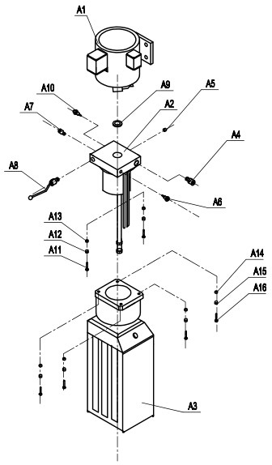

No. | Name | Qty | No. | Name | Qty
A1 | Motor | 1 | A9 | Sheet gasket | 1
A2 | valve element | 1 | A10 | Choke plug | 1
A3 | Tank | 1 | A11 | M5X40hexagon screw | 4
A4 | Down-regulating  valve | 1 | A12 | Φ5 Flat gasket | 4
A5 | Choke plug | 1 | A13 | Φ5 Spring washer | 4
A6 | Oil-out | 1 | A14 | M6X20 hexagon screw | 4
A7 | Oil-out | 1 | A15 | Φ6 Flat gasket | 4
A8 | Hand valve | 1 | A16 | Φ6 Spring washer | 4

    - Hydraulic system

a．Hydraulic principle

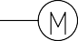
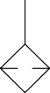
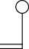

b．Parts list
A9 | Cylinder |  |  | 1
A8 | solenoid |  |  | 1
A7 | One-way  valve |  |  | 1
A6 | Falling  throttle valve |  |  | 1
A5 | Oil pump |  |  | 1
A4 | Flood valve |  |  | 1
A3 | Tank |  |  | 1 | 10L
A2 | Filter |  |  | 1
A1 | Motor |  |  | 1
No. | Name | Model | Standard | Qty | Remark

c. The hydraulic system works as follows:

When pressing the start button on the hydraulic station , the motor starter to drive the pump suction pressure from the tank and oil is carried into the serial A9 fuel tank, so that the piston rod to move. The A4 flood valve closed, the pressure is fine before leave factory . To ensure that the requirements of lifting rated load. However, the system pressure exceeds the limit, automatic flood valve unloading. Release the start button, stop oil supply to enhance the end, began operations work. If you decline, the first point of action to rise a little, after the mechanical safety lock is opened, pressing the manual valve A8 and began unloading decreased.

Electrical schematic diagram (380V three-phase motor) (220Vsingle-phase optional)
(* Installation sure to follow the schematic wiring to ensure reliable the ground at the ground, the input power leakage, over-current protection switch must be set)

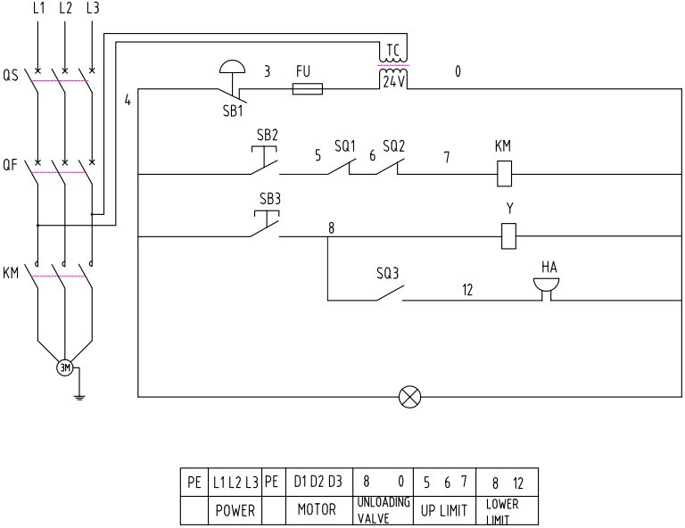

Code |  | Product Name | Qty
QS |  | Power switch | 1
QF |  | Mini circuit breaker | 1
FU |  | Fuse | 1
SB1 |  | Emergency stop button | 1
SB2 |  | Up button | 1
SB3 |  | Down button | 1
KM |  | A.C contactor | 1
HA |  | Buzzer | 1
TC |  | Transformer | 1
HL |  | Indicator light | 1
Y |  | Descending solenoid valve | 1

9.Trouble shooting

No. | Symptom | Eliminating methods
1 | A motor does not turn | - check the power supply has power  - Check the motor connection box wiring is loose
2 | motor rotation position of pressure oil | - One-phase electric rotating in the wrong direction, swap in which two into line.  - Check that the fuel tank suction tube is off
3 | Hydraulic lift after the slow  decline in(Pressure bad) | - cleaning one-way valve and reversing valve of  the hydraulic station.
4 | Security lock laughs at locksmith | - observe the position of locksmith security hook plate is normal.  - observed the location of column is correct  - Check the return spring safety hook plate
5 | motors, electrical failure | - Promptly cut off the power to inspect, repair  and replacement by a professional electrician..

10. Packing list

 |  | Pack part
No. |  | Product Name | Qty
69 |  | Power unit | 1
70 |  | 9/16Point power unit connector | 1
71 |  | ￠14 Copper gasket | 1
 | 35 | M8X35 Bolt | 4
 | 53 | ￠8 Flat washer | 8
 | 46 | ￠8 Spring washer | 4
 | 61 | M8 Nut | 4
73 |  | Big control box | 1
 | 27 | M6X20 Round head bolt | 4
 | 52 | ￠6 Flat washer | 4
 | 45 | ￠6 Spring washer | 4
 | 59 | M6 Nut | 4
77 |  | Travel switch | 1
 | 25 | M5X15 Round head bolt | 4
 | 51 | ￠5 Flat washer | 4
 | 44 | ￠5 Spring washer | 4
78 |  | Button box | 1
 | 26 | M6X15 Round head bolt | 2
 | 52 | ￠6 Flat washer | 2
 | 45 | ￠6 Spring washer | 2
63 |  | M10Nipple | 1+4+4
43 |  | M19expansion bolt | 16
 |  | Circular notched flat mat | 20
 |  | Ribbon | 10

11.Wearing parts list

No. |  | Name
77 |  | Travel switch
82 |  | Cylinder slider
83 |  | Multiplying wheel
84 |  | Oilless bearin-35
92 |  | Pulley
93 |  | Oilless bearin-25
97 |  | Cable ￠ 9.53，L=4215
98 |  | Cable ￠ 9.53，L=6936
 | 16 | Electromagnet assembly
103 |  | Limit wheel
106 |  | Beam slider

